**VIETNAM NATIONAL UNIVERSITY HO CHI MINH CITY**

**UNIVERSITY OF INFORMATION TECHNOLOGY**

**ADVANCED PROGRAM IN INFORMATION SYSTEMS**

**LE SANH PHUC - PHAM TANG TUNG**

**ADVERTISEMENT SYSTEM IN MOBILE PLATFORM**

**WITH AUGMENTED REALITY**

**BACHELOR OF ENGINEERING IN INFORMATION SYSTEMS**

**HO CHI MINH CITY, 2015**

**VIETNAM NATIONAL UNIVERSITY HO CHI MINH CTIY**

**UNIVERSITY OF INFORMATION TECHNOLOGY**

**ADVANCED PROGRAM IN INFORMATION SYSTEMS**

**LE SANH PHUC 11520288**

**PHAM TANG TUNG 11520462**

**ADVERTISEMENT SYSTEM IN MOBILE PLATFORM**

**WITH AUGMENTED REALITY**

**BACHELOR OF ENGINEERING IN INFORMATION SYSTEMS**

**THESIS ADVISORS**

**ASSOC. PROF. DR. TRAN MINH TRIET – MSC. LUONG VI MINH**

**HO CHI MINH CITY, 2015**

# ASSESSMENT OF ADVISORS

………………………………………………………………………………………………………………………………………………………………………………………………………………………………………………………………………………………………………………………………………………………………………………………………………………………………………………………………………………………………………………………………………………………………………………………………………………………………………………………………………………………………………………………………………………………………………………………………………………………………………………………………………………………………………………………………………………………………………………………………………………………………………………………………………………………………………………………………………………………………………………………………………………………………………………………………………………………………………………………………………………………………………………………………………………………………………………………………………………………………………………………………………………………………………………………………………………………………………………………………………………………………………………………………………………………………………………………………………………………………………………………………………………………………………………………………………………………………………………………………………………………………………………………………………………………………………………………………………………………………………………………………………………………………………………………………………………………………………………………………………………………………………………………………………………………………………………………………………………………………………………………………………………………………………………………………………………………………………………………………………………………………………………………………………………………………………………………………………………………………………………………………………………………………………………………………………………………………………………………………………………………………………………………………………………………………………………………………………………………………………………………………………………………………………………………………………………………………

# ASSESSMENT COMMITEE

………………………………………………………………………………………………………………………………………………………………………………………………………………………………………………………………………………………………………………………………………………………………………………………………………………………………………………………………………………………………………………………………………………………………………………………………………………………………………………………………………………………………………………………………………………………………………………………………………………………………………………………………………………………………………………………………………………………………………………………………………………………………………………………………………………………………………………………………………………………………………………………………………………………………………………………………………………………………………………………………………………………………………………………………………………………………………………………………………………………………………………………………………………………………………………………………………………………………………………………………………………………………………………………………………………………………………………………………………………………………………………………………………………………………………………………………………………………………………………………………………………………………………………………………………………………………………………………………………………………………………………………………………………………………………………………………………………………………………………………………………………………………………………………………………………………………………………………………………………………………………………………………………………………………………………………………………………………………………………………………………………………………………………………………………………………………………………………………………………………………………………………………………………………………………………………………………………………………………………………………………………………………………………………………………………………………………………………………………………………………………………………………………………………………………………………………………………………………

ACKNOWLEDGEMENTS

We would like to express our gratitude to advisors, Associate Professor PhD. Tran Minh Triet and MSc. Luong Vi Minh who suggest, instruct and encourage us during the time we do thesis.

We would like to express my thankful to Mr. Le Trung Nghia – an elder brother from class Advanced Program in Computer Science 2008 in Ho Chi Minh University of Natual Science for their advices in researching Vuforia framework.

We appreciate the charity of JetBrain and Microsoft corporation. They have supply the all free professional, utimate software licenses to students that help us a lot of things not only in the thesis, but also in our study in university. Somee and GitHub also recommends free hosting, server to us.

We would like to express my thankful to the staffs in Faculty of Information Systems of University of Information Technology who emit the passion to us as well as equipt us enough basic kwnoledge in the recent year.

We should say thank you to our family for providing us the best conditions to study in Advanced Education Program and finish this graduation thesis.

Although we have try effort to finish this thesis in suitable range and our best abilities; certainly it can not avoid the disadvantages and errors, we respecfully wait for sympathy and feedbacks of our Lecturers and friends. We sincerely say thank you.

Winter 2015,

Le Sanh Phuc – Pham Tang Tung – Student of CTTT2011

TABLE OF CONTENTS

ASSESSMENT ii

ASSESSMENT COMMITEE iii

ACKNOWLEDGEMENTS iv

TABLE OF CONTENTS v

LIST OF FIGURES ix

LIST OF TABLES xii

ABSTRACT xiii

Chapter 1 Introduction 1

1.1 Introduction 1

1.1.1. Augmented reality, potential applications 1

1.1.2. Mobile Devices 4

1.2 The motivation to do the topic 5

1.2.1. Advertisement, economic trend 5

1.2.2. Advertisement on mobile 10

1.2.3. Forms of promotion 13

1.2.4. Topic idea 16

1.3. Objective 17

1.4. Content of topic 19

Chapter 2 Overview 20

2.1. Augmented reality 20

2.1.1. Augmented reality 20

2.1.2. Augmented reality applications in advertising 23

2.2. Overview about Vuforia 26

2.2.1. Introduction 26

2.2.2. Foundation structure of Vuforia 27

2.2.3. Fundamental knowledge about Vuforia SDK 29

2.2.4. About Vuforia 31

2.3. Conclusion 31

Chapter 3 System Architecture and Technolical solution in backend 32

3.1. Solution architecture 32

3.1.1. 2-tiers architecture and 3-tiers architecture 32

3.1.2. Application of 3-tiers architecture in the system 34

3.2. Services layer 37

3.2.1. Problem 37

3.2.2. Solution -WCF 37

3.3. Data access layer 39

3.3.1. Problem 39

3.3.2. Solution – NHibernate framework 39

3.4. Result 39

Chapter 4 Some problems and Technical solution in Manager Module 41

4.1. The objectives of the management module 41

4.2. Processes of Admin’ functions 43

4.2.1. Create, View, Edit, and Delete customer 43

4.2.2. Create, View, Edit, and Delete company account 43

4.2.3. View statistic 43

4.3. Processes of Company’ manager’ function 44

4.3.1. Create, View, Edit, and Delete campaign 44

4.3.2. View statistics 49

4.4. Solution 49

4.3.1. Flow 49

4.3.2. Technologies 49

4.5. Result 55

4.6. Conclusion 56

Chapter 5 Architecture of presenter module 57

5.1. About presenter module: 57

5.2. Architecture of presenter module: 57

5.2.1. Components in presenter module: 57

5.2.2. The process of identifying target: 58

5.3. Management of augmented information objects module: 59

5.3.1. Handling specific description of augmented information module: 60

5.4. Some problems and solutions to build presenter module: 63

5.4.1. Develop database connections between Presenter module and Server. 63

5.4.2. Connecting to the network. 65

5.4.3. Show list as listview in Android. 66

5.4.4. Display augmented information on Camera 68

5.4.5. Demonstrating augmented information 70

5.5. Result 72

5.6. Conclusion 73

Chapter 6 Conclusion 74

6.1. Results 74

6.2. Development 79

REFERENCES 81

LIST OF FIGURES

Figure 1-1 Picture of the movie "Who Framed Roger Rabbit?" 2

Figure 1-2 Google Glass - the future of AR 2

Figure 1-3 Top 5 Augmented Reality SDK's 3

Figure 1-4 The number of mobile devices and mobile operating systems 4

Figure 1-5 The graph show the number of print almost decreased in a lot of region, especially Western Europe and North America 6

Figure 1-6 Google ads income. 8

Figure 1-7 Percentage of online shopping customers in Vietnam. 9

Figure 1-8 Season of mobile devices and Advertising on mobile platforms is crowned. 11

Figure 1-9 Advertisement on mobile 12

Figure 1-10 Cimigo is one of the big company in researching market. 14

Figure 2-1 Myron Krueger interacted with video place. 21

Figure 2-2 The application uses the reality enhancement. 22

Figure 2-3 Google Glass path guide. 23

Figure 2-4 the application software enhanced reality in advertising. 24

Figure 2-5 Performance on the device of the Volkswagen car. 25

Figure 2-6 The development of Vuforia system 26

Figure 2-7 Overview about the process of development application by Vuforia framework 28

Figure 2-8 Model of AR application developed by Vuforia SDK 30

Figure 3-1 Physical and logical view of 2-tiers architecture 32

Figure 3-2 Physical and logical view of 3-tiers architecture 33

Figure 3-3 Application of 3-tiers architecture in the system 34

Figure 3-4 Common module in solution 35

Figure 3-5 Solutions structure of manager module and services 36

Figure 3-6 The mechanism of RESTful 38

Figure 3-7 Service project 40

Figure 3-8 Data Access project 40

Figure 3-9 System architecture 40

Figure 4-1 Structure of manager module 41

Figure 4-2 Use case diagram of Admin 42

Figure 4-3 Use case diagram of Company’ manager 42

Figure 4-4 Process of creating new campaign 44

Figure 4-5 Enter campaign information 45

Figure 4-6 Enter mission information 46

Figure 4-7 Enter AR information used for uploading target, building AR data 46

Figure 4-8 Sequence diagram of creating new campaign 47

Figure 4-9 Activity diagram of creating new campaign 48

Figure 4-10 Process flow in manager module 49

Figure 4-11 The Map built by Subgurim control 50

Figure 4-12 The Statistics chart show the percentage of customers by age and sex. 51

Figure 4-13 Create Vuforia Cloud Database 52

Figure 4-14 Pairs of keys in Vuforia 52

Figure 4-15 Some pictures in manager module 56

Figure 5-1 Overall architecture of Presenter module…………………………………...57

Figure 5-2 Process of handling augmented information……………………….………59

Figure 5-3 Architecture of Management of augmented information object…...60

Figure 5-4 Demo about Preseter module…………………………………………………….72

Figure 6-1 Check-in campaign………………………………………………………….…………76

Figure 6-2 Theater campaign……………………………………………………………………..77

Figure 6-3 Tour campaign…………………………………………………………………………..78

LIST OF TABLES

Table 4-1 Fields in request body to create, update target. 54

Table 4-2 Return result of creation new target API .55

ABSTRACT

Advertisement is the fundamental method of marketing. The target of advertisement is to provide information and attract customer to pay attention about corporations, products, or services of suppliers. By the progressive development of economy, advertisement plays important and indispensable role. Moreover, mobile market grows more and more with the provident of the diversity of every classes, every ages of customers; especially smartphone and tablets. Therefore, the advertisement transfers gradually from the tradition ways like newspapers, magazines, poster… to TV, radio and mobile advertisement now.

Customers have a lot of activities with diverse points to accumulate points, promotion programs is concreted, and difficult to manage. By the above reason, there is potential solution about what integrated system is built to face with the demands of customers as well as corporations. Hence, we offer building a system that is able to add augmented reality as a new feature of solution. Augmented reality is created by two primary mechanisms: image information and location information.

The system has do experience with 3 categories of campaigns – build 8 campaigns and 27 missions. The system contains 2 modules:

***Management module*** is built in web platform by ASP.NET Web Form Application. The abilities of the module is to support companies’ managers to build themselves a campaign to advertise products, manage assests interactively in a short time. In additional, the module also help managers to have a general seen and evaluation about products, strategies through statistic tables. The module also allows admin of the system to manage customers and companies.

***Presenter module*** is built in mobile platform running in Android operating system. In this module, the users oriented target is personal customers. By using the application, users are able to register and participate in campains built by producers with all detail information about missions of each desireable campain. The important and emphasized point of this module is the ability to show augmented reality information visualization to viewers: Social Media (Facebook, Twitter, Youtube …), Multi Media (Video, Audio, Text …). Moreover, the module also help users interact with augmented reality information such as share, comment, review, and read their personal information or relative feedbacks of other users.

Chapter 1

**Introduction**

*The content of Chapter 1 introduces about traditional advertisement, mobile market and forms of promotion. From this data, we analyze the limited points of these ways to find the approach methods of application of augmented reality in advertisement. Base on the ideas, we express the objectives of this thesis. Chapter 1 also mentions about augmented reality generally, the trends of application about augmented reality now. By the end of this chapter, we summarize the primary content of each chapters in the thesis.*

1.1 Introduction

### 1.1.1. Augmented reality, potential applications

Augmented Reality (AR – Augmented Reality) is a variant of the Virtual Environments (VE - Virtual Environments), or normally known as virtual reality. VE is the technology takes the user into a synthetic environment. While using this technology, users cannot see other around things in the real world. In contrast, AR allows users to see the real world, with the Virtual World; objects are overlapped or combined with the real world. Thus, AR supplements the real world rather than completely replace. In the best case, everything appears for the reason that users see virtual and real objects exsiting in the same space, similar to the effect achieved in “Who Framed Roger Rabbit?” Figure 1-1 shows an example of how this can yet. This shows a real desk near a real phone, beside is a virtual lamp and a chair. Note that the object is a combination of 3-D, Virtual lamp and two chairs are the inclusion of the actual table. AR can be considered as the "combination" of VE (complete virtual) and Telepresence (completely true) [1]



**Figure 1-1 Picture of the movie "Who Framed Roger Rabbit?"**

Augmented reality is one of the potential development in the future. More and more organizations and businesses invest in research AR; notably Google is the giant in the village of technology now. Project "Google Glass "Figure 1-2 is the realization of the ambition of dominating AR technology of this “search” giant. Style, functionality and efficiency of this smart glasses still needs to be verified; but need to confirm that Google and Google Glass possesses special advantage that no other company in the world can compare are: Google Search.

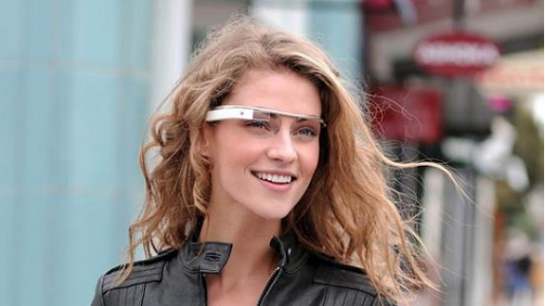

**Figure 1-2 Google Glass - the future of AR**

By the search system, Google controls the entire flow of information in online world. The role of Google in the Internet is identical to the role of a coach when you travel in the area being completely new. Information are almost in everywhere but what you see, know, or feel which is fully dependent or heavy dependent on what the tour guide just for you.

The launch of Google Glass can fully take search and supply information technology to a new level - temporarily dubbed the "interactive search" – ​​when users can completely search without any further action of the arms, all are absolutely conducted due to voice recognition engine. Combined with the huge amount of information controlled by Google, this can see that Glass is ready to stir technology world in the near future. [2]

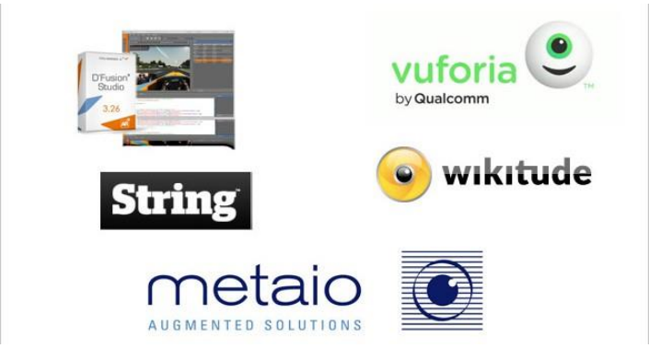

**Figure 1-3 Top 5 Augmented Reality SDK's.**

**(Source: http://augmentedrealitynews.org/ar-sdk/top-5-augmented-reality-sdks/)**

AR can bring the best unprecedented user experience. From the provements, it can be judged that the development potential of AR in the future is very bright. However, there exists a number of ideas indicating AR is finally just a flashy marketing of technology manufacturers. This opinion is not correct, for AR applications now do not have high realistic features, and are not apply on large range. Therefore, to make AR become future technology, manufacturers need to focus on resources in both sides: content and hardware.

In terms of content provision, AR technology needs to focus on the educational or entertaining aspects. We can confirm that success or failure of AR is determined by two trends: image and sound recognition. Feature “image recognition” allows users to learn the depth of product and motivates innovation. Feature “sound recognition” opens up new opportunity for traiditional communication tools to interact with consumers. [2]

1.1.2. *Mobile Devices*

Today, mobile devices are familiar to everyone – there are many mobile devices everywhere in the world with different types, shapes, sizes, and categories – good enough to satisfy all class, age, gender, and region.

The development of the mobile device industry is growing faster. According to the Market research (2013):

* 91% of people on earth use at least one mobile phone.
* 56% of people have smart phones.
* 50% of phone users choose phone as primary device to access internet.
* 72% of users use tablets for transactions every week. [3]

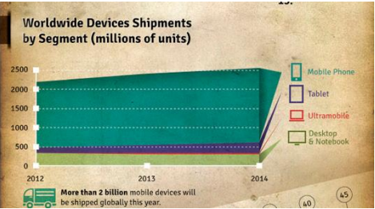

**(a) More than 2 billion devices sold in 2013**

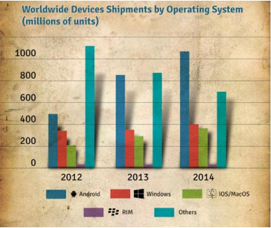

**(b) Numbers devices running mobile operating systems**

Figure 1-4 The number of mobile devices and mobile operating systems.

Not only had the development of the device, but the operating system used on the devices also the top priority standard of customers. Among them the most prominent operating systems are iOS (Apple), Android (Google), Blackberry OS (Blackberry), Windows Phone (Microsoft). Android has led with the number of devices using the operating system at more than 1 billion.

Today, the popularity of mobile devices depends on the price. Because equipment suppliers regularly produce the product quality with variety of designs and reasonable prices that attract many users. For each person, consultation and selection issue to review and buy himself or herself a tablet or a smart phone is very simple.

The number mentioned above help us somewhat to see the development of applications as games, graphics applications, utility programs, advertising ... on mobile devices has always been the preferred choice of software developers.

## 1.2 The motivation to do the topic

### 1.2.1. Advertisement, economic trend

Advertisement is “*the method of propagation with fee or without fee in order to introduce information about products, services, companies or ideas, advertisement is the indirect activity between people and people that the advertisers must pay money for public multimedia to transfer information to the receivers in order to persuade or impact them*.” ([4])

The traditional advertisement methods send information by many different ways such as: newspaper, TV, poster, leaflet… They have the limited point that the information is **limited in space, the number of information** is easy to be are usually **static information**: image, video, audio, text. The **misunderstood** and they **cannot transfer the message at all**; especially the **receivers do not have ability to interact** with the receive information. The individual person, organization that do the advertisement may also be **difficult to have the exact statistic, evaluation about the effect** of this advertisement.

**Advertising in newspaper and magazine**

There are two kinds of advertisement which may be seen in newspaper and magazine: group by categories and group by images. The models of advertisement by categories are small behind newspapers when the others by images are diverse with almost every sizes, from the small angle of one page to two consecutive pages.

The type of advertisement is very expensive and not effective. If we choose small publishers; although this can save fee, we cannot receive the attention of many viewers, or selection of arbitrary magazine does not attract different kinds of readers.

The content of newspapers, magazines is lack of information. The information are usually very short, do not express many feature points of products. This way is only good in the case that the advertisers just want to show contact information, services information, transaction and reality of the information is depended on who are the publishers.

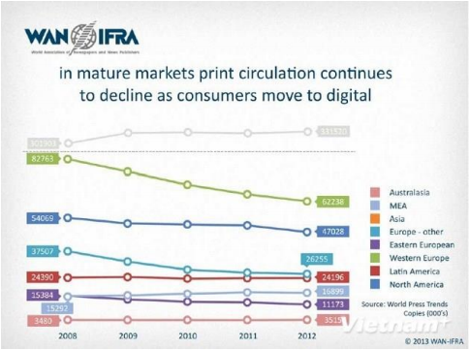

Figure 1-5 The graph show the number of print almost decreased in a lot of region, especially Western Europe and North America.

**(Source: *WAN-IFRA)***

Nowadays, the trend of users gradually change from traditional newspapers to electrical news. Therefore, the effectives, profits of advertisement in traditional newspapers, magazines also reduce. According to the analysis of Chisholm Institute (Australia) on the press in Southeast Asia in Vietnam, the number of print edition per one thousand population is 60 sheets (in Southeast Asia, Singapore is the top position with 349 sheets). Indonesia is currently the largest in the region in terms of growing publishing rate with 29%, and Vietnam is equal to 0, Singapore is -6. Regarding profits from advertising on the print, Singapore leads with 489 USD per sheet, Vietnam is 15 USD, the lowest number in the region. Revenue from advertising in newspapers of Vietnam in five years ago has also tumbled 9%, this is the strongest rate of decrease in Southeast Asia.

**Advertising on TV**

Television is often called the "king" of conventional advertising media information, because most people spend more time watching television than in the daytime for other media. Television combines the use images, color, sound and motion ... and the combination of these factors creates effective. Television has demonstrated admirable strength by continuously affecting human behavior. Users buy the kind products and services that they have read and heard a lot on television.

This form of advertising is very expensive, only large enterprises have the ability to use forms of advertising. In addition, the design and building of footage advertising is not just a small challenge for many companies. Normally, TV viewers are familiar with the subtle advertising and therefore familiar with the expectation of watching the high quality ads. A sketchy advertising footage can seriously reduce the effectiveness of the message advertising, and even could create a bad image in the minds of customers.

Due to the amount of information consumers have recognized each day already overloaded, the opportunity of newspaper ads or TV has impressed enough to influence and persuade consumers use becomes very low. According to research by the Gallup Institute (largest market research corporation in America'): in 1965, just run a television ad 3 times in 3 consecutive days during peak hours on a national television channel, they can achieve the level of brand recognition by housewives group was 90%. In 2002, the ad runs needed to achieve 90% identify as 137 times in peak hours. The effectiveness of media channels has declined badly, while that ads costs rose so high that hardly acceptable.

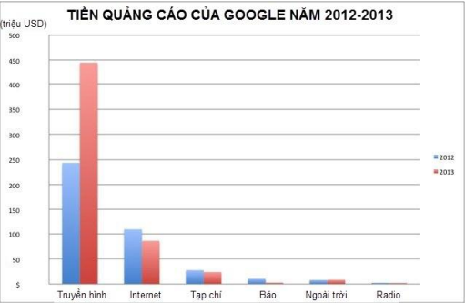

**Figure 1-6 Google ads income.**

**(Source: http://cafebiz.vn/quang-cao-thuong-hieu/chart-google-chi-bao-nhieu-tien-cho-quang-cao-ky-thuatso-2014042817041719013ca110.chn)**

**Advertising on the Internet and Mobile**

Today, in the era of information technology break out, internet is an advertising method that are more and more preferred. By the internet, we can pass lots of message content, and there is an interaction with the recipient information. When customers are looking for information and services, besides the specialized pages looking like google.com, yahoo.com, bing.com ... there are many specialized sites ads, classifieds, directories... that are accessed by many people for looking information. However apart from the specialized advertising pages in the main sites, the remaining web is often not achieved high advertising effectiveness. These ads menu popup or rudimentary advertisement pages always annoy users; they always suspect that these ads can be links with computer viruses.

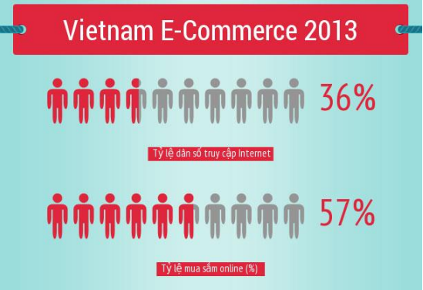

**Figure 1-7 Percentage of online shopping customers in Vietnam.**

**(Source: According to the e-commerce and Information Technology department)**

In addition, the explosion of mobile devices also contributes to the advertising via the Internet more effectively. Information is passed to the hands of people using a quick and convenient way; with a mobile device with a network connection; we now have a huge repository of information. Advertising on mobile devices; beyond user access to the website to see the ads on the device's web browser, there are two other methods: advertise through SMS (messages on the phone) and via other applications.

Advertising via SMS usually from the one central telephone to the large number of other mobile phone to advertise. Users are mostly uncomfortable and always skip this ad messages. Advertising via the app is one of the advertising way that give back the largest revenue. By this way, ads are popped up in the application of the mobile device or even outside the main screen of the device. However, advertising via SMS or through other applications nor draw users because of the lack amount of information transmitted to the user.

Today, the development trend of advertising industry is aimed at making the reduction costs, increasing efficiency. The developers are switching from ads marketing information through television, newspapers, radio to the Internet and mobile devices, because they target potential user groups, managing the statistic about level of interest, tastes of the users to contribute improving the effectiveness of ads. Internet advertising solves most of the restrictive than the traditional advertising, reducing costs; however, the method itself also has **limitations that conveys the information to the desirable user group encountering many difficulties** and users do not **tend to pay attention on this ad information** (users often ignore, disable ad statements, and regard it as spam ...).

1.2.2. *Advertisement on mobile*

Advertisement is a basic form of marketing, the purpose of it is to attract the interest of users to business, product or service which supplier bring out. Along continuous development of economy, advertising plays an important and indispensable role.

Nowadays, people can find and see ads everywhere: from posters, banners, leaflets or video shown on television every day.

The consumer market has become very competitive with a newborn brand. Despite of the product you are looking for or quantity of brands, which are available, are interested, concern of each marketer normally is to promote their brand with a good image than their competitors.

Advertisement is to broadcast, communicate a message of the service or new product to public / consumers as the flow of information about a product or services from the seller to the buyer. However, advertisement does not end with the flow of information alone but also to go further, to influence and persuade public to make a desirable action such as buying products.

As report of e-Marketer published in The Guardian, revenue of mobile platform advertisement overtakes revenues of advertisement in newspapers and magazines in print England with distances of up to several billion pounds in the next year.

Similarly, in 2016, the predicted revenue from mobile advertisement beyond revenue of advertisement on television with the expected number to 4.5 billion pounds (equivalent to about 7.7 billion USD). [5]



Figure 1-8 Season of mobile devices and

Advertising on mobile platforms is crowned. [6]

The Guardian references from e-Marketer – the largest marketing agency, media and US market, said that revenue of advertisement on mobile platforms in 2014 in UK is estimated about 2.02 billion £ and has a current record pace: 96%.

According to experts, British print revenues and magazines in 2014 was approximately to 2.06 billion pounds. By the current gains, revenue on mobile advertisement overtakes printing industry soon.

This is considered as inevitable development trend of the era of mobile devices to the throne. E-Marketer estimates that up to 2018, about half the British population owns each one iPad, Kindle, or a similar type of tablet.

In 2015, the mobile advertising market grows further 60% with expected revenue reaching approximately 3.2 billion pounds while advertisement on newspapers and magazines would only take 2.7 to 2.8 billion pounds.

This is a giant step. 4 years ago, the entire revenue of mobile advertising market in English is only evaluated about 83 million pounds, but so far, this number has increased nearly 3 times and there is no signs of stopping. Experts predict that in 2016, revenue of mobile advertisement remains at about 38% growth and get 4.46 billion pounds.

Meanwhile, revenue of television advertisement in equivalent time (2016) is only at about 3.8 billion pounds.

At the moment, the total market of digital advertising in the UK is estimated at about 7.25 billion pounds, is expected to increase 7.97 billion pounds in 2015 and hit 8.64 billion pounds in 2016.

In 2014, revenue of advertisement on mobile is just about 30% of the previous numbers, but by 2016, this ratio increases over 50%.

However, the advertising information to a client about the existing of a brand is not enough. Advertisement need focus to potential targets in such a way to create a positive impact on the clients and in the process, this creates brand recognition. Therefore, marketers often target in advertising campaign in the group for clients.

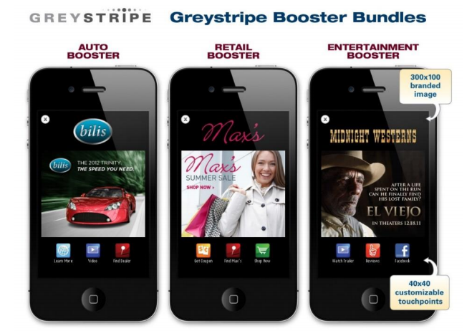

Figure 1-9 Advertisement on mobile

In additional, advertisement in the traditional ways now still has disadvantages points as:

* Users cannot view many contents that they need. They can only look on a poster or on a leaflet.
* The information given to consumers is not dynamic: text, image (on leaflets, posters).
* Do not review the content which consumers are interested in when seeing ads on TV.
* Fees for advertisement on television, posters are very high.
* Failed to interact with content or company.
* Difficult to attract different classes that companies target.

Difficult to perform statistical evaluation about the level of attention of customers using the product, see the ad. The compliment from users are not fully collected in exact way and this leads to the wrong orientation in business strategies.

### 1.2.3. Forms of promotion

Besides advertising, communication, marketing managers also launched the promotional activities to attract, entice users to purchase products them. Promotions can be divided into 3 categories according to different objectives:

**Market survey promotions**

The category of promotion helps companies to operate the economic development strategy for a new type of item. By this method, they usually give the trial products, bundled with other products. For example, buying a bottle of shampoo attached a new kind of shower gel bottle. They even organized a market research campaigns, workshops, forums for consultation feedback and tastes of the user. There are currently many companies involved doing market surveys, they launch promotional items, coupons that are incentive for users. Their strategy that users give them the information, opinions, feedback on the type of product being studied. Then the opinion survey is sold to the production company.

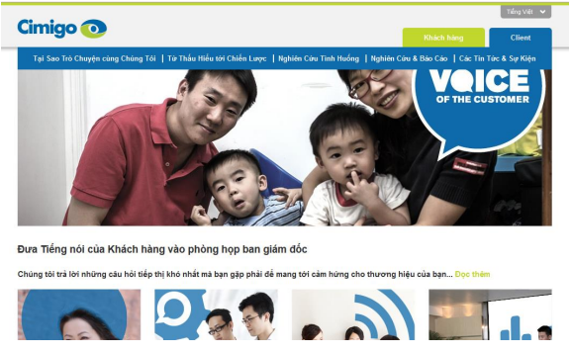

**Figure 1-10 Cimigo is one of the big company in researching market.**

**Enhance sales promotions**

This is the most common promotion, company discounts or donates accompanying product even give away their products. More than ever, price is the key element in marketing and it makes customers buying or avoiding product. A study of Cahners - Advertising Research Report shows that 98.7% of customers affected by the price when they buy a certain product.

The establishment of the product requires very complex calculations and futuristic science. Most studies show that products with prices ending in odd numbers achieved retail sales higher products with prices ending in even numbers. About 80% of the products, prices end in nine or five.

Jo Marney, a consultant of advertising / media in Toronto says that: "Pricing is a complex science and it is varied by product and market. Many basic marketing books emphasize that prices ending with odd numbers (e.g. 1, 3, 5, 7, 9), or near a certain round number (e.g. 99, 98) increase the sensitivity customer. In 1969, Lawrence Friedman (author of Psychological Pricing in the Food Industry) indicated that certain prices have an impact on the mind of shoppers come from a long-standing practice, because he found the prices ending with number "9" or "5" occupy nearly 80% of retail food prices. Nearly 50% of discount promotion is a multiple of five, but the even number sale off are more dominant. [6]

**Branding promotions**

This categogy of advertising is not intended for a specific product, it is applied to a company brand. To perform this form of promotion, companies often create a compelling and catchy logo, a piece of music or a slogan associated with the company's image; and try to put the images, sentences to the community (through television, newspapers, social activities...). Besides, issuing membership cards, loyalty cards is one way that helps building the image in the eyes of users. By the guest card, companies entices huge amounts of potential, loyal customers. Customers return to use company products several times to get the priorities of the company.

Saving stamps (Saving stamps) is one of the programs to create first loyal guest. Sperry & Hutchinson introduced the Green Stamps introduced S & H - S & H Green Stamps - in Jackson, Mississippi in 1896 with the aim of simply to reward loyal customer. General Mills introduced Betty Cocker’s scoring bonus in 1920. In 1950, the tobacco manufacturing company started to celebrate the loyalty program by a coupon enclosed in the pack.

Loyal customers program began thriving in the 1980s. The airlines was the first companies to recognize the potential of this promotion type.

Customer card program was created in the mid-1980s by a lot of series of major hotels including Marriott, Holiday Inn, Radisson and Hyatt. A study of Radisson shows 70% of visitors surveyed are affected by promotion.

Today, it is calculated that 60% of Canadians having guest card loyalty, while nearly 70% of American shoppers have participated at least a loyalty program. The loyalty program is based on a fundamental argument that 80% of total sales come from 20% of total customers, regardless of what program is. A company can ensure reaching finance target if attracts 20% of customers.

The loyalty programs as Air Miles, Optimum and Aero plane in Canada not only help push revenue, but also help to companies had better understand their customers. Zellers has maintained its loyalty program for 15 years. Club Z has nearly 10 million members, of which 7.6 million members regularly buy products each month. [7]

### 1.2.4. Topic idea

From the assessment of the limitations of traditional advertising methods and the rapid development of AR technology mentioned above; group has proposed the better solution for the deployment of the advertising program. It is the use example internet, mobile devices and **application of augmented reality in order to help the advertisement, disseminate information efficiently and more enjoyable**.

In fact, there were some projects applying AR technology in advertising but they mainly just stop at the trial, study or simply polish names for famous brands through fun and fresh AR products, they do not really aim at finding effective advertising.

To make the media programs, promotional information become no longer boring, monotonous with static information, the augmented reality helps users having more expanded information, fascinating, and multi-dimensional, real-time updates. It also helps users having interactive feedback. Advertisers have the exact statistic numbers to make the program more effective. That is the purpose of the construction of the **applications of augmented reality systems in advertising industry**.

## 1.3. Objective

Because the advertising section is a very broad field with the large number of products (electronic products, home appliances, industrial goods ....) so that group decides to build a demo system in particular business that is the field of advertising based on movie titles. Therefore, the interaction between real users with products revolve around the topic about selection and watching movies at the cinemas.

The objective of this research is to develop a system for managing integrated advertising campaigns on mobile devices with augmented reality technology; and construction of the augmented reality presenter module in the form of multimedia, social media information on mobile devices (Android platform) following the campaigns that have been already defined.

The system consists of two main modules:

* ***Management module* (Manager):** This is a website built on the ASP.NET platform. It allows managers to build advertising, promotion programs using augmented reality by the simple operations.

The main functions of the module are:

- Additional augmented resources in multi-media formats (image, sound audio, video ...), social-media (web links for reference, blog, forum ...) and interactive activities if there is (implementation the survey questions, like, share, and comment on products ...) any picture of the product.

- Develop advertising campaigns: promotion, gifts, sale off, offer the activities interacting with the user...

- Manage advertising campaigns: change the duration of the campaign, perform statistics by multiple criteria (people who have attended, time, age, gender of users).

- Show all the products and attached augmented resources for users (not necessarily managers) having a global view about the ongoing products and the campaigns.

- Provides API for creating interactive bridge between databases with mobile devices and the web.

* ***Presenter*** ***module* (*Presenter*):** built on the Android platform, the module allows users to scan an image which has been uploaded to the database and performances augmented objects. Some key functions of this module includes:

- Allows users to register, login account.

- Show ongoing programs, advertising campaigns, the new campaigns, and the campaigns which users have participated...

- Display of the tasks and interactive activities with users, promotion and benefits of users.

- Allows users to scan images of products to show augmented resources, information of products.

- Allows users to like, share, comment, and feedback about products.

- Show support, instruction for user to use interactive activities, complete the tasks, and get the rewards, benefits...

## 1.4. Content of topic

Thesis consists of 6 chapters:

**Chapter 1**: Overview of the potential of augmented reality, mobile devices market, the practical application of augmented reality and the status of advertisement now. By the limited points of traditional advertisement and the development of augmented reality as well as mobile market, we motivate to implement the project and objectives of the topic.

**Chapter 2**: Jump start in augmented and application of this technology in mobile advertisement. In this chapter, group also introduces about Vuforia framework.

**Chapter 3**: Describe the general architecture, basic design of the system and explain the technology of back end in the system.

**Chapter 4**: The main objective of the Management Module is to help to support the enterprise customers for management advertising campaigns. Because the process of implementing this system, group cannot avoid internal problems about content and we raise these issues and approach methods (solution) which we applied. Moreover, the content of chapter introduce about processes as well as structure of Management Module.

**Chapter 5**: This chapter focuses on augmented reality of Vuforia: The architecture of the Vuforia application, Architecture of SDK, some features or supported functions. Furthermore, this chapter describes these issues and solution that helps group to solve the problems when we build the Presenter Module.

**Chapter 6**: Summary, present the achieved results and the development of dissertation.

Chapter 2

Overview

*Chapter 2 presents an overview of augmented reality. Next is an introduction about Vuforia framework that group applies in the system.*

2.1. Augmented reality

2.1.1. *Augmented reality*

Augmented reality is the image processing from the surrounding environment in real world to determine the object and provide augmented information for founded objects and equipment. The application is programmed, built by integration to handle information received through the camera on the mobile device. The camera of mobile devices recognize and analyze the founded object (probably shaped object, photo or text and usually a range of bar codes in black and white color) which help the programmers to determine ways to add augmented information (text, pictures photos, audio or video ...) for the object and display to the users by the following ways:

Determine position, angles of found objects (planar data) than the camera's devices to draw information on the right marked spatial 3-D position. Or draw the 3D object.

Show augmented information about objects on users’ devices and additional features that users can interact with service providers.

The common point of the two methods is that the user can interact directly to augmented information. Augmented information are met in real time. AR only beginning to meet the needs of military and industry. When applying somewhere outside laboratory, AR become popular demand in social life.

Augmented reality appeared soon in the 1950s:

* 1957-1962: Morton Heilig - a cinematographer has created and been patented the invention of a device called Sensorama simulator providing pictures, sound, vibration, and scent.
* 1975: Myron Krueger created Video Place that allows users to interact with virtual objects for the first time in the world.

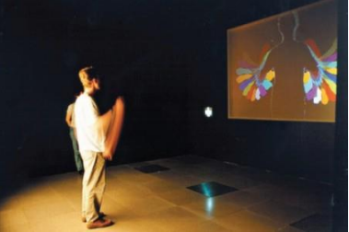

Figure 2-1 Myron Krueger interacted with video place.

* 1980: Steve Mann was the one who created the first wearable computer in the world - is a vision system computer with text and graphics overlaid on the actual image.

The system was further developed until 1990, the term "augmented reality" is officially used and who coined the term is a researcher of Boeing - Tom Caudell. Then, this technology is developing rapidly.

One typical application may include is the use of CAD (Computer Aided Design) to simulate the assembly of an aircraft, military, health care ... This technology is also used widely in the fields of advertisement, marketing.

In fact, this technology has proven to be very useful in today's life. When tied to place determination technology, some applications are built to help display to users of a grocery store, clothing store or shopping to identify traffic stations, the nearest visited destination...

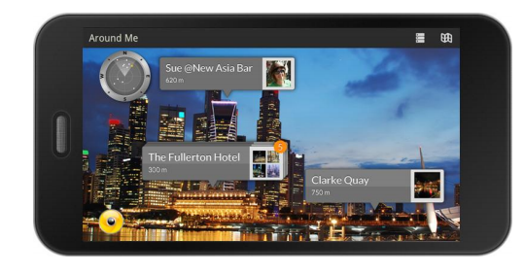

(A) The application Wikitude allows to search recent services around you.

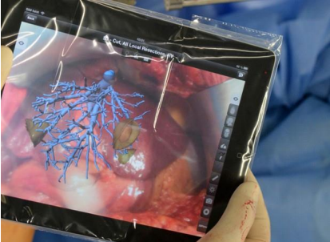

(B) The liver surgeon technological devices using AR.

Figure 2-2 the application uses the reality enhancement.

**(Source:** [**http://www.wikitude.com/app/how-to-use-wikitude/**](http://www.wikitude.com/app/how-to-use-wikitude/) **,** [**http://www.engadget.com/2013/08/22/fraunhofer-ipad-app-guides-liver-surgery/**](http://www.engadget.com/2013/08/22/fraunhofer-ipad-app-guides-liver-surgery/)**,** [**http://timesofindia.indiatimes.com/tech/slideshow/googleglass/Translate/itslideshow/18609226.cms**](http://timesofindia.indiatimes.com/tech/slideshow/googleglass/Translate/itslideshow/18609226.cms) **)**

In the medical field, this technology can give the surgeon the information which cannot be seen as: heart rate, blood pressure, the anatomical patient ... AR can be used to help doctors to look inside in a patient’s body by providing an X-ray image.

The most recent is the born of Google Glass devices announced by Google in 2013 with the notable feature:

* Navigation system on this device informs you exactly what you need to turn in street corner, displays a map surrounding area via Google Maps.
* Foreign language translation directly on the screen of Google Glass.
* Search for information of the products you see in front of your eyes then displays directly onto the device.

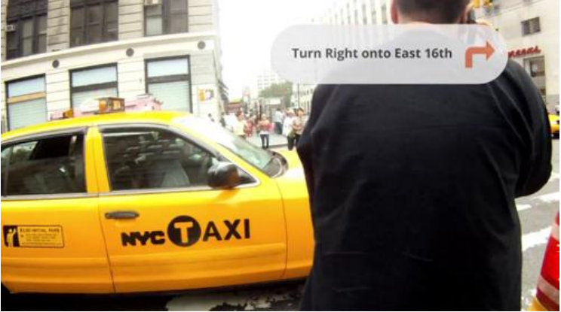

Figure 2-3 Google Glass path guide.

2.1.2. *Augmented reality applications in advertising*

Based on the providing information, the goal is to attract a large number of customers and minimize the current advertising restrictions as we can. The application of *augmented reality* technologies in advertising is one of modern options and highly appreciated.

Today, there are many enterprises applying this technology on the mobile devices to promote his company's products to the public. This provides a good solution for bringing their image or helping the user to interact directly to the products.

From May 1/2011, REAL Group (France) real estate company provides free REAL me application on iPhone, iPad and Android phones that help users to buy or rent houses, apartments at the desired location. When the lens phone towards certain buildings belonging REAL Group, users can REAL me get information about the apartments they are targeting, superimposed images obtained by tube glasses.

(a) REAL me app supplies information about department in France).

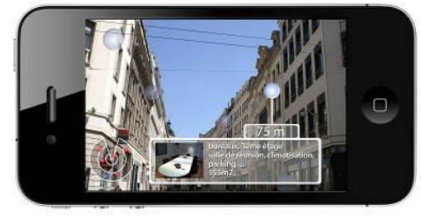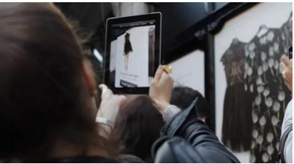

(b) The user views Apartments of Net-A-Porter.

Figure 2-4 the application software enhanced reality in advertising.

(Source: <http://echip.com.vn/thuc-tai-tang-cuong-a20130314160058393-c1107.html> )

9/2011, Net-A-Porter company decorated the entire store's clothing Alone in the big city like Paris, New York, London, Munich Photos by images in the collection of Karl Lagerfeld. Passersby are instructed how to download an application of company here. Users simply open the application and scanned image of the product through the device's camera. Immediately, the message about product information is displayed to the user view: specs, video demo clothing test samples, prices ... besides those users can select to how purchases and how to do online payment on the application.

Alternatively, as an advertising campaign of Volkswagen company in Canada. In 9/2011, car producers have urged people to download application VWJuicedUp to device. When the application has been installed, users simply use their mobile devices installed applications at the marked point on advertising board given by car producers. At this time, on the device - viewers are treated to a performance of the car reflected on advertising board that users towards. The car runs from advertising board and performances. [8]

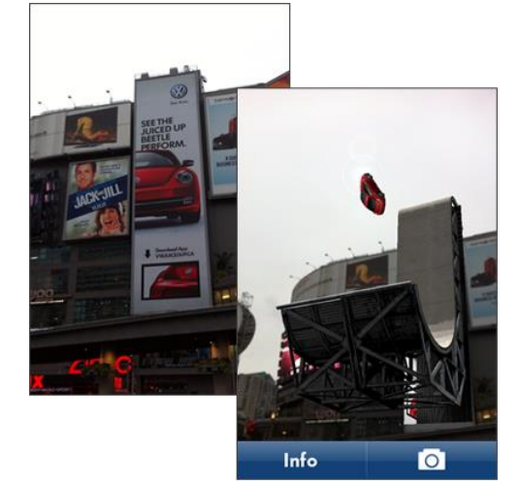

Figure 2-5 Performance on the device of the Volkswagen car.

(Source: <http://randymatheson.com/?p=668>)

How to apply *augmented reality* technology to advertisement to bring benefits for business: the interests of users, low cost, high popularity, convenience (direct purchases)...

It is sure to conclude that the number of people using mobile devices is increasing. By this reason, the common level using applications of third parties is proportional. When the application is downloaded, the scan an object, image, or text which provides plenty of needed information to them, promote their curiosity. As long as content augmented information of provider are attractiveness, interesting, creative and good interaction and meanwhile the increase number of clients using *augmented reality* applications are great turning point for the advertisement industry and services.

2.2. Overview about Vuforia

2.2.1. *Introduction*

Vuforia is a framework supporting augmented application of Qualcomn research center. Today, Vuforia supports Android, iOS and Unity 3D platforms. Vuforia supplies a lot of features supporting developers in creation augmented application running in many devices which does not require good knowledge in the aspect.

Vuforia is awarded Auggie for the best framework supporting augmented reality at Augmented World Expo 2013. By the donation of many large corporation as Audi, Viking, Lowe’s, Moosejaw, Sesame Street, Johnson… with the large society with more than ***60,000 developers*** in ***130 countries*** and more than ***4,500 applications*** (according to <https://www.vuforia.com/>), Vuforia is one of the best choices to build augmented reality application.

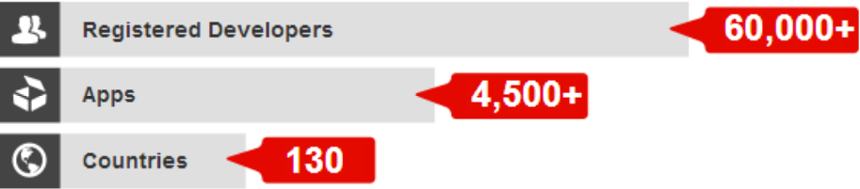

Figure 2-6 The development of Vuforia system

(Source: <https://www.vuforia.com/>)

Vuforia use computer vision technology to recognize and track image targets and 3D objects, such as box in real time with high quality even though hide condition and lack of light. From the recognized images, developers can present virtual objects as 3D model, augmented image in mobile screen. Targets are tracked in real time in order to match the vision angle of viewers and vision angle targets. It must satisfy the condition that virtual objects are part of real world.

By many features, Vuforia gives a hand in creation high quality application being able to interact with 3D images in real world giving customers a lot of new experiences in mobile devices.

**2.2.1. *Features***

Supported features in Vuforia:

* Recognize target by local data in devices or data in Cloud Recognition server with the number of suitable stored targets equal 1,000,000. Moreover, users can self-defined (user-defined) when application runs (run-time).
* Tracking one or multiple targets whenever users move devices around Image Target.
* Recognize 5 targets at the same time in hide condition and lack of light.
* Optimize to assure the high quality of graphical image in target.
* Vuforia supplies API (Application Programming Interfaces) written by C++, Java, Object-C, and .NET (through the extension of Unity game engine). By this way, SDK of Vuforia support in development in native code in both Android and iOS platform as well as make porting from Unity easily. Therefore, AR application using Vuforia is compatible in many mobile devices such as: iPhone, iPad, Android phone and tablet.

2.2.2. *Foundation structure of Vuforia*

Figure 2-7 Overview about process of development application by Vuforia framework supplies a general view how to build application with Vuforia. The platform includes Vuforia Engine, Target Management System stored in information data of Target Manager, and Cloud Target Database.

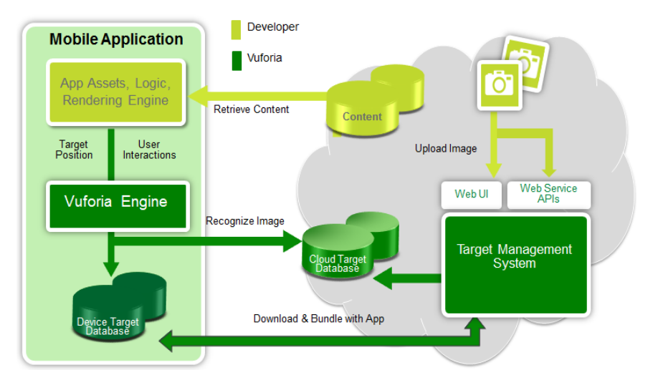

Figure 2-7 Overview about the process of development application by Vuforia framework

**(Source**:***https://developer.vuforia.com/sites/default/files/dev_guide_images/getting_started_SDK_devguide/Vuforia_Components_SDKsection.PNG )***

The process of development Vuforia application contains:

* Developers upload images of targets that they want to track to Target Management System.
* Them, developers use libraries supplied by Vuforia Engine as “share object – libQCAR.so” in Android or “static library – libQCAR.a” in iOS).
* Vuforia applications access to relative resources of tracking targets in two ways:

a. Access databases of targets from Cloud Target Database through web service.

b. Download databases of targets into devices and package with application.

2.2.3. *Fundamental knowledge about Vuforia SDK*

AR application developed by Vuforia SDK comprises following components (Figure 2.8 Model of AR application developed by Vuforia SDK):

* Camera: components in camera assure that each view is saved and passed to Tracker as efficient as possible. Developers can just start Camera and stop Camera. View automatically transfer to dependent device to format image and its size.
* Image Converter: Convert image format from camera format (YUV12) to suitable format of OpenGL ES to build image (RGB65) and do internal tracking. The convert also contain down sampling image in order to make image of camera in different resolution in camera change stack.
* Tracker: tracking components contain vision algorithm to recognize and track target in real world in camera. Based on image in camera, algorithms find and recognize targets or new marker and review virtual button. Results are store in state object used by Video Background Renderer and can be accessed from application code. Tracker can download multiple databases at the same time and active them.
* Video Background Renderer: display images from camera stored in object state. Video Background Renderer is optimized in different devices.
* Application Code: Developers have to initialize the above components to perform 3 main steps in application code. Each camera is processed, object state is updated and vision method is called. Developer must:
* Query object state to get information of targets, markers or states of another component.
* Update logic of application with new input data.
* Show image or 3D model which is relative to the target.
* Device Databases: Device Databases are created by using Target Manger. Data of targets is download in XML form that allows developers to configure particular feature and binary file containing database for tracking. Assets are compiled and packaged in installer of developers, and then used in run-time of Vuforia AR SDK.
* Cloud Databases: Cloud Databases are create by using Target Manager or Vuforia Web Services API. Targets are queried in run-time of application by cloud recognition feature. Cloud Databases can also contain metadata.
* User-Defined Targets: There is another way is that users define targets themselves. The feature allow users to create targets from current image in camera. Targets are saved in particular AR session.

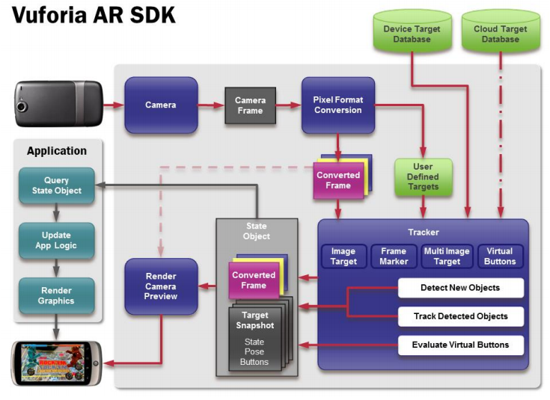

Figure 2.8 Model of AR application developed by Vuforia SDK

(Source:*https://developer.vuforia.com/sites/default/files/dev_guide_images/getting_started_SDK_devguide/vuforia_data_flow_diagram.png)*

2.2.4. *About Vuforia*

Vuforia platform is one of the most AR framework application and the best tool of image recognition. Vuforia supplies interesting features in multiple platforms such as iOS, Android and Unity 3D for developers to build native application.

2.3. Conclusion

The content that group presents in Chapter 2 shows the overview augmented reality and its application. Then, we introduce about Vuforia framework as well as its contribution in AR application development to figure out the reason which we choose the technology to do our thesis.

# Chapter 3

**System architecture and**

**Technical solution in backend development**

*Content of chapter 3 presents general architecture of the system and the technology which group uses to implement back end component.*

## 3.1. Solution architecture

**3.1.1. *2-tiers architecture and 3-tiers architecture***

***3.1.1.1. Limitation of 2-tiers architecture***

2-tiers architecture is typical client-server system that server runs a DBMS for storing and retrieving physical data and optionally business execution (store procedure); and client is fat client. The client is responsible for connecting to server to exchange data, applying business rules, managing transactions, presenting data to the users and collecting input from users, resolving concurrent access problem,…

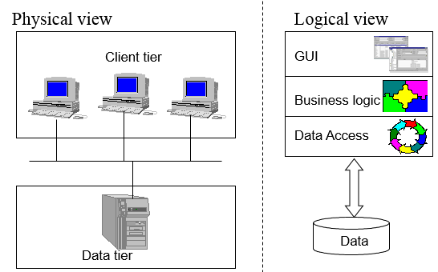

**Figure 3.1 Physical and logical view of 2-tiers architecture**

**(Source: ELCA Ltd training document)**

As the figure above, in 2-tiers architecture, client and server interact directly to each other. This has the some advantages as well as disadvantages points.

**Advantages**

Application can be easily to develop. Database server and business logic is physically closed, which make higher performance.

**Disadvantages**

The 2-tier model is lack of scalability because it only support a limited number of users. Moreover, server must process a large request centrally.

***3.1.1.2. Advantages and disadvantages of 3-tiers architecture***

To overcome with the disadvantages of 2-tiers architecture, the model of 3-tiers architecture are born. Data tier are the same; however, it has an application server (business tier) that implements and applies all business rules. Client tier are the same, but it does not connect to Data tier directly. Instead of doing this, client send request to business tier. Sometimes, the server load balance are available for process a large number of requests.

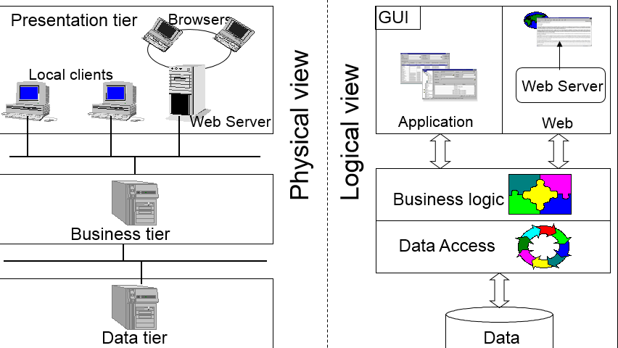

**Figure 3.2 Physical and logical view of 3-tiers architecture**

**(Source: ELCA Ltd training document)**

The **advantages** of this model is the ability to reuse code, effective running application. Moreover, the scalability (load balancing, connection pooling…) is also the most important factor that we must concern. For the view of developers, the model allows to separate clearly modules. This makes us easily to maintain and upgrade.

However, 3-tiers architecture still has some **disadvantages** such as: more infrastructure work and complex architecture. It takes more time and budget for implementation.

**3.1.2. *Application of 3-tiers architecture in the system***

***3.1.2.1. Why we use 3-tiers architecture***

By the time after researching augmented reality and its application, mobile market, ways of promotion, group decide to choose 3-tiers architecture for the system because:

* We think that the system is interesting. If it is widely applied, 3-tiers architecture is suitable because of the scalability.
* Many modules in the system are implemented concurrently, so division into small parts make us easily to fix, repair or update in the future.

***3.1.2.2. Architecture***

Based on 3-tiers architecture, we design the system as the Figure 3.3 below. In each tiers (physical view)), there are one or many layers to perform suitable functions.

**Common**

**WEB & APPLICATION**

**PRESENTATION TIER**

**SERVICES**

**DAO**

**BUSINESS TIER**



**DATA TIER**

**Figure 3.3 Application of 3-tiers architecture in the system**

The **data tier** contains 1.mdf file (extension of MS SQL Server database file) and its backup files, log files.

The **business tier** contains 2 layers:

* Data access layers (DAO) plays only 1 primary roles: access directly to database (supported by ORM framework – NHibernate) to perform CRUD operations.
* Service layers provides interfaces to clients meaning web application (manager module) and mobile application (presenter module) for accessing to data in defined ways that are defined. All business logic, exception handling, and concurrent update handling are processed in the layers and serializable to other layers.

The **presentation tier** is the diverse definitions. In generic term, it contains 2 primary terms: web application (manager module) and mobile application (presenter module). To explain exactly the meaning of presentation tier, we set it comprising all mobiles devices which use the presenter module application and all devices that use the manager module web.

**Common** section defines a lot of classes, helpers, extension methods that are used in many different ways. For examples:

* Dto: The NHibernate mapping (ORM definition) classes that map with tables in database design.
* JsonHelpers: A class contains methods for parsing classes to JSON and vice versa as well as parsing XML to JSON and vice versa.
* ExtensionMethod: Brings the Append() method of StringBuilder to String (C#)
* Services interface: Interface for clients to call services API.

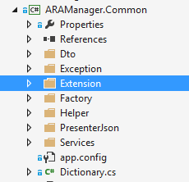

**Figure 3.4 Common module in solution**

***3.1.2.3. Implementation***

Every components in the system is transparent, this means it can just see its dimension as:

* Clients can just see Presentation (Client services factory – a class for getting services)
* Presentation can just see Services
* Services can just see Data access

All of them has one general point is that one common module. Figure 3.5 describe how the architecture of the system except presenter module and data tier.

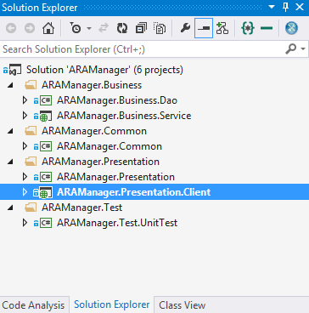

**Figure 3.5 Solutions structure of manager module and services**

## 3.2. Services layer

### 3.2.1. Problem

Develop web service system to help query data operation, information are concerned from both Modules: Manager and Presenter in an efficient way.

### 3.2.2. Solution -WCF

Group proposes to build a system providing Web Service API supplying functions to query based on RESTful architecture.

***What is RESTful?***

REST is given to apply a constructive way and simple web service perform operation of main complex concept of traditional Web Services.

REST stands for Representational State Transfer - in the sense of allowing users to access resources - resource (is data before and after handling or functionalities of the applications) – Web services application through URL.

Mechanisms between server and client is point to point.

The data is transmitted directly over HTTP and is accessed via HTTP under MIME format without SOAP format - reduce complexity - for simplicity, we shall consider data and functions as parameters or data transmission attached in HTTP

Allowing data manipulation under 4/7 method defined in HTTP as GET, POST, PUT, DELETE to clearly specify how to manipulate data on the server, what are accessed, what are edited, which are displayed and hidden ...

Requests when using REST:

* Client and Server: Client and Server must talk using the same interface and protocol
* Use the layers architecture and do not store status after the process is responded
* Cache Memory: the return value is stored in the client
* Code on Demand: clients obtain data in the returned value after processes in servers are completed.
* Uniform Interface: each client resource is accessed through unique address and use the defined method.

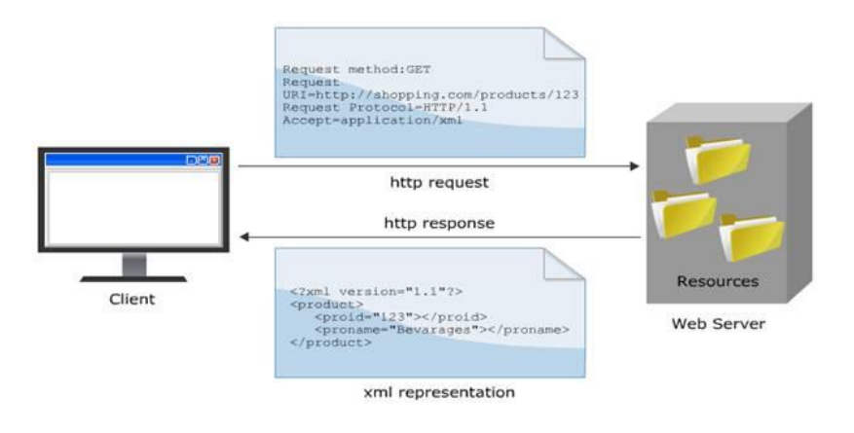

**Figure 3.6 The mechanism of RESTful.**

**(Source: http://kieutrongkhanh.net/index.php/java-web-service-x/79-gii-thiu-v-restful-web-services)**

***Why choose RESTful?***

Nowadays, in the world, there are two kinds of common architectures used to build a Web Service system are: RESTful and SOAP. Here would be the comparison between two buildings on.

We can perceive some benefit in using RESTful are:

* Do not depend on any intermediary system - as SOAP and WSDL do.
* The design using RESTful transmits data via protocol HTTP allows internal applications to use in an easy and powerful way: Asynchronous JavaScript + XML / JSON (Ajax).
* The strong combination of AJAX and RESTful also makes more developers to learn and use.

## 3.3. Data access layer

### 3.3.1. Problem

Build an ORM to map object model to database model for easily working.

### 3.3.2. Solution – NHibernate framework

Object-oriented and relational database may be cumbersome. NHibernate is an object/relational mapping tool for .NET environments. Object/relational mapping (ORM) refers to the technique of mapping a data representation from an object model to a relational data model.

NHibernate also help developers in:

* Data query and retrieval facilities in compare with manual data handling in SQL and ADO.NET
* Useful with object-oriented domain models and business logic
* Remove or encapsulate vendor-specific SQL code
* Help with the common task of result set translation from a tabular representation to a graph of objects.

## 3.4. Result

We successfully create NHibernate mapping between database schemas and object model, define services for both manager and presenter module. The data access project are built to handle transaction, concurrent update; exceptions are also serialize all solution.

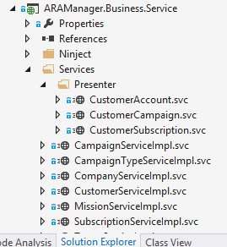

**Figure 3.7 Service project**

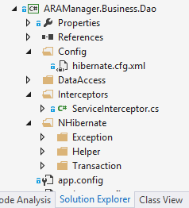

**Figure 3.8 Data Access project**

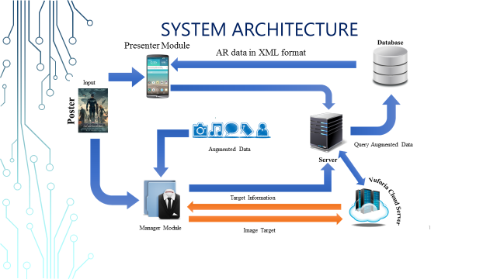

**Figure 3.9 System architecture**

# Chapter 4

**Some problems and**

**Technical solution in Management module development**

*Content of chapter 4 presents some problems encountered in building management module, interface issues, and expressing information. In Chapter 4, group also presents the ASP.NET technology to the module.*

## 4.1. The objectives of the management module

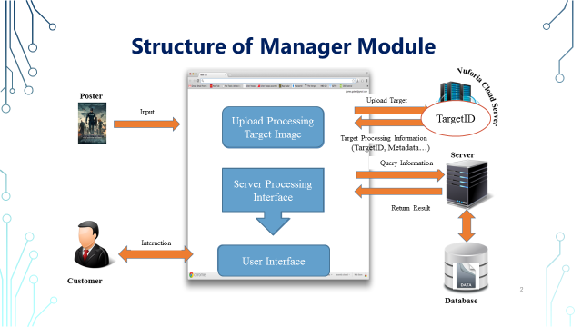

**Figure 4-1 Structure of manager module**

The module contains 2 types of users:

_ Admin: the module supports admin to manage customers and companies account as well as view statistics.

_ Company’ manager: Group builds the module to support in the design augmented information to perform show in presenter module. This module allows marketing managers to build advertising campaign with augmented information; do statistics, manage campaigns and users that have joined the campaign.

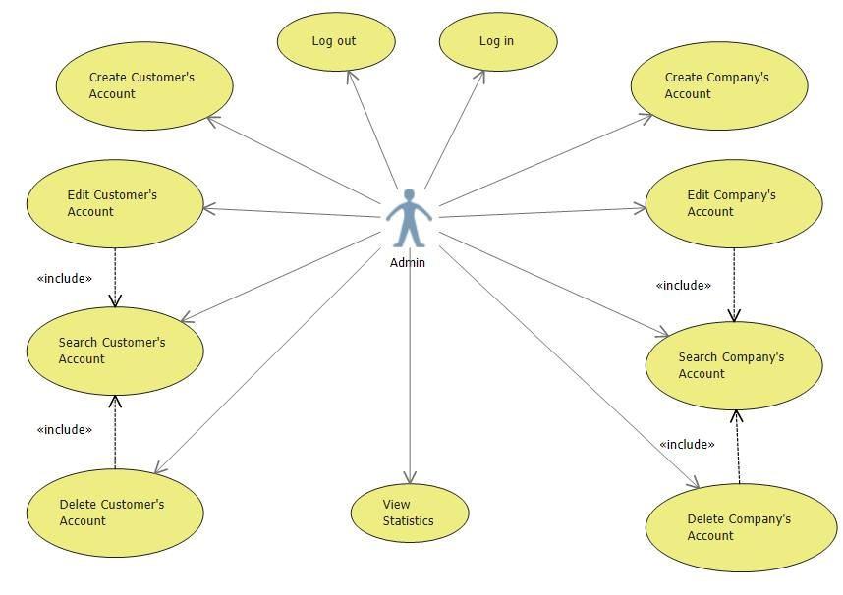

**Figure 4-2 Use case diagram of Admin**

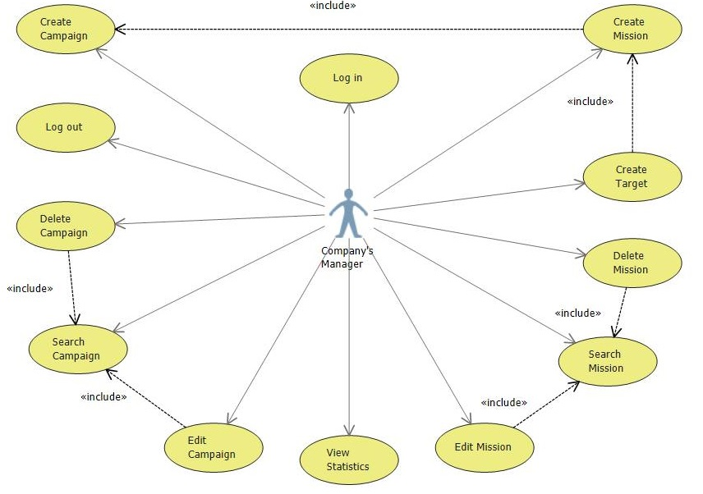

**Figure 4-3 Use case diagram of Company’ manager**

## 4.2. Processes of Admin’ functions

### 4.2.1. Create, View, Edit, and Delete customer

After login to system, Admin users can select section “Customer” to go to Customer manager page.

At this page, admin can search customer by Username… Then the search result containing list of suitable customers are returned. Admin are able to edit, delete or update information of any customers by simple clicking on his or her id, the action navigates to edit page.

There is another functions is to create new customer account for Admin role. The function is built to face with the case that company directly to Admin instead of sending information of company through email.

### 4.2.2. Create, View, Edit, and Delete company account

After Admin receive information of company through email or direct request, he or she go to “Company” management page to company account.

Admin can also search company by Username to view and/or edit information. He or she can delete the company account in system if there is any suitable reason such as company leaves the system, company violates regulation, and company does not work now…

### 4.2.3. View statistic

The statistic function let Admin follow the rate of customers by male and female, age. From the result, Admin recognize the development of system to make suitable business plan.

## 4.3. Processes of Company’ manager’ function

### 4.3.1. Create, View, Edit, and Delete campaign

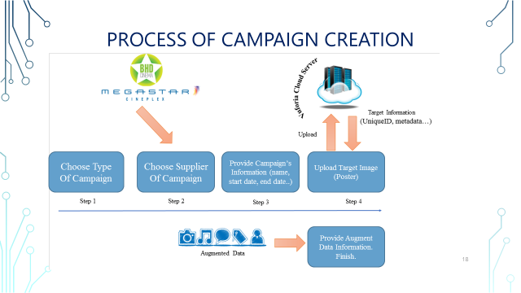

**Figure 4-4 Process of creating new campaign**

Adding a new campaign displayed on the interface of web browsers by 3 following steps:

* *Step 1*: Choose category for a new campaign: check in, tour and theater. Regarding this category of campaign. If the system applies widely, we will have variety of different campaigns, not only encapsulated in 2 or 3 categories as test systems.

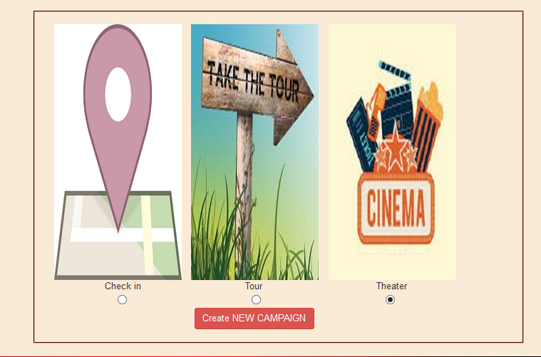

**Figure 4-5 Campaign page (1)**

* *Step 2*: Provide information about the campaign. The required information of campaign here: campaign name, start date and time, end date and time, a brief description about the campaign. The number of tasks needed to be complete.

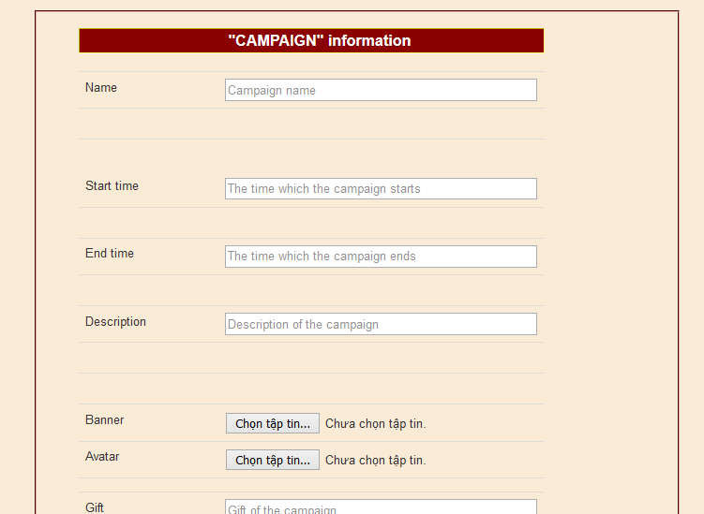

**Figure 4-5 Campaign page (2)**

* *Step 3*: Provide information of missions. At this stage, the number of missions provided in Step 2 describes clearly. For each mission, users need to upload pictures for using in each respective mission. At this step, website builds and supplies a particular site for users to upload pictures. Required information of images that are Link and Image Name (no space).

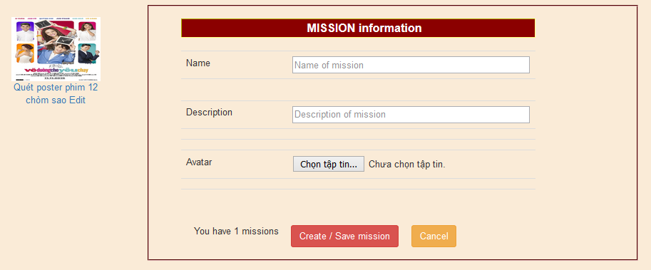

**Figure 4-6 Enter mission information**

* After the posting step completes, the image uploaded to the Cloud Server and analyzed. The process is long or fast depending on the size and complexity of color in photos. Target Id of each target is stored in database.
* In addition, since this is a campaign about the movie so the needed information providing for tasks are about movies information: movie name, actors, director, manufacturing year ...

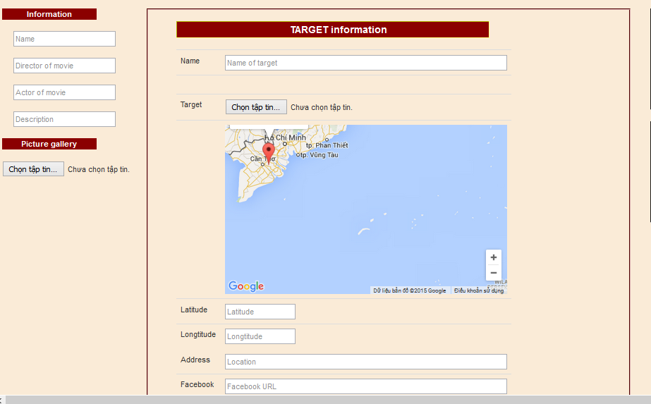

**Figure 4-7 Enter AR information used for uploading target, building AR data**

Since the image information processing on Cloud Server is invariant, no fixed time depending on image quality and complexity of images, to make sure about the time required for the program may start running, users should wait after 2-3 hours.

After completing 3 above steps and approximate 2-3 hours waiting for processing images on the Cloud Server, campaign design is complete and it can start working.

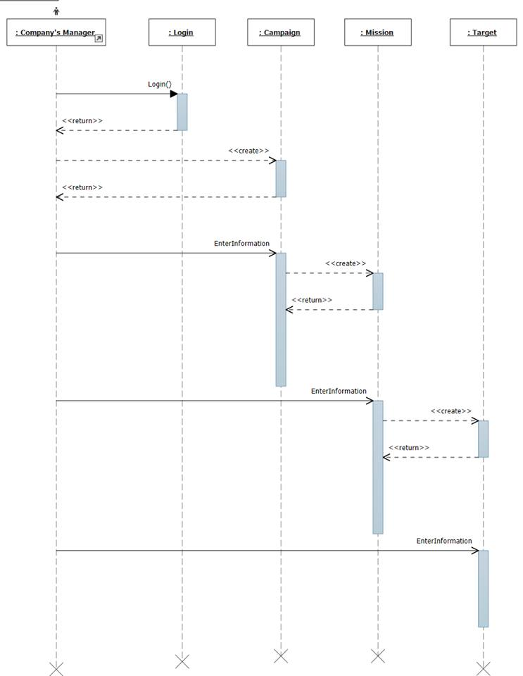

**Figure 4-8 Sequence diagram of creating new campaign**

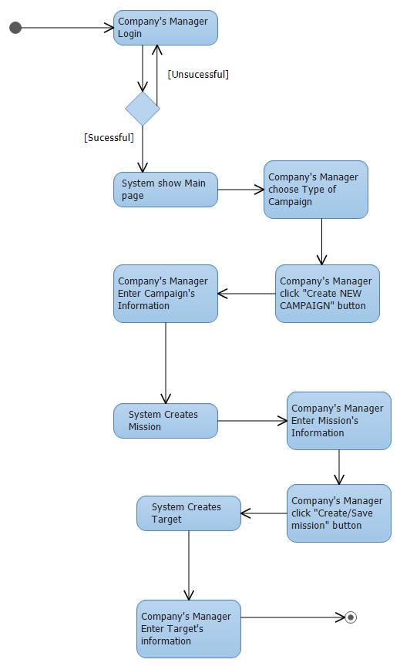

**Figure 4-9 Activity diagram of creating new campaign**

### 4.3.2. View statistics

The statistic function let Company’ manager track the rate of joining customer in each campaign to plan the new suitable strategy in the next campaign or stop inefficient campaign.

## 4.4. Solution

### 4.3.1. Flow

**Services**

**Client Service Factory**

**Clients**

**Data access**

**Figure 4-10 Process flow in manager module**

### 4.3.2. Technologies

#### *4.3.2.1. Show Map*

***Problem***

In manger module, group has built functional map to guide users the direction and location to complete mission.

***Solution***

To draw the map up on the web, group uses Subgurim Map – the most advanced Google Map API for ASP.NET. The control brings the full power of the official Google Map API v3 without JavaScript code in .NET. Another advantage point of Subgurim is that we do not need to register with Google, Subgurim do it for us.

***Result***

By applying Subgurim Map control, group builds the function that show map in target information page. When company’ managers create targets, they can point to the location of the target that satisfy their mission’ demand.

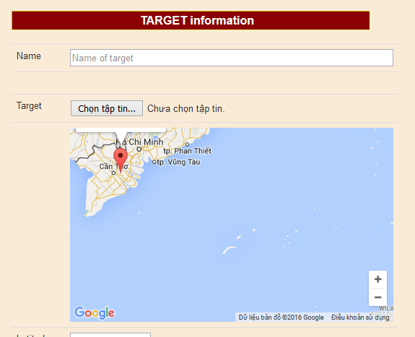

**Figure 4-11 The Map built by Subgurim control**

#### *4.3.2.2. Show statistics charts*

***Problem***

In each campaign, company’ manager wants to summarize, review that rate of joined customers in the program. Admin also needs to check the rate of members in system by age or sex.

***Solution***

In the manager module, group builds statistical chart serving the marketing managers. To have the exact statistical and intuitive numbers, group` has studied and used chart of AJAX control toolkit.

AJAX control toolkit may not be a perfect way to display data on the web page with diverse types of chart: area chart, bar chart, pie chart, line chart, bubble chart; however, in the demand of the system, we think that it provide us enough functions.

***Result***

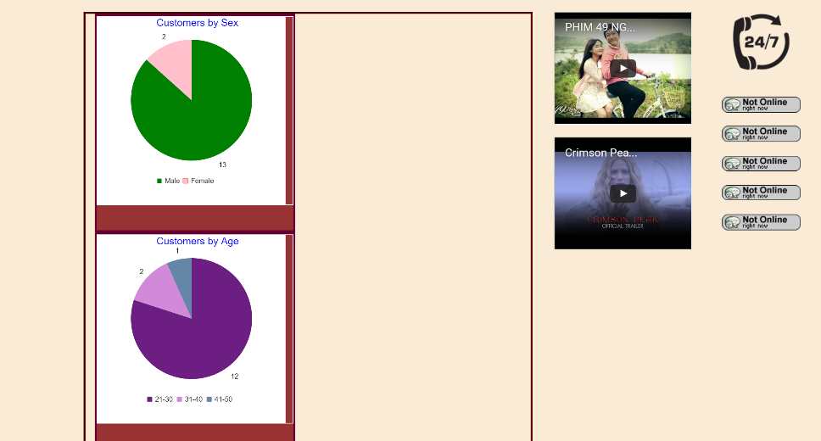

**Figure 4-12 The Statistics chart show the percentage of customers by age and sex.**

#### *4.3.2.3. Bootstrap*

***Problem***

By the development of mobile devices, that group introduces in 1.1.2, the rate of customers ***using mobiles*** to accessing manager module is ***very*** ***large***. This requires the website has mobile interface.

***Solution***

Bootstrap is a collection of CSS and JavaScript that strongly supports design layout of a web-based interface. Bootstrap supports many Web browsers on computers as well as mobile devices. Today, there are millions of websites being designed thanks to this framework. By more than 200 icons and hundreds of professional effects, Bootstrap can help us to quickly have the most delicate site layout in a simple way.

#### *4.3.2.4. Vuforia*

***Problem***

Company’ manager needs a tool to recognize their posters and show augmented data to customers.

***Solution***

Vuforia section supports customer to upload target to Vuforia Cloud Server for presenter module. The main features of the section is to upload, edit, delete target.

**Using Vuforia API**

To use API of Vuforia, developers need to register account at website <https://developer.vuforia.com/>. Login with the recent register account, select Target Manager > Cloud Database > Create Database (Figure 4.7). Enter name of database then click Create.

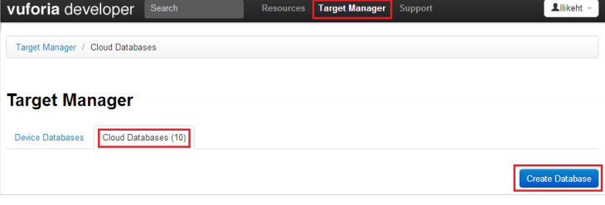

**Figure 4-13 Create Vuforia Cloud Database**

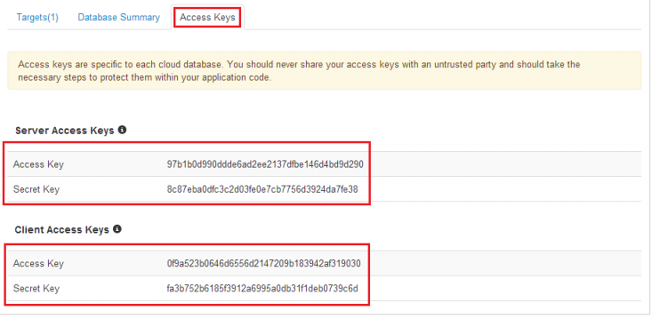

**Figure 4-14 Pairs of keys in Vuforia**

Each database is created with a pair of server access key and server secret key. API of Vuforia can just be used to add, delete, edit, and get information of target of particular database. Therefore, if developers want to create different databases, the only way is to use GUI web. To get a pair of keys of database, click on the database > Access Keys. The pair of server access keys is used by API for add, updating, delete target. The pair of client access keys is used in presenter module to recognize target and get Meta associated with the target.

**Authentication of Vuforia**

Vuforia does not used Oauth method to authenticate. Each API request has to add Authorization environment to header. The header has form:



Signature is built:

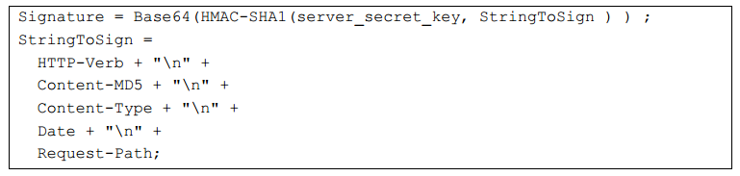

Notes:

HTTP-Verb: GET/POST/PUT

Content-MD5: hash value MD5 of body, if HTTP verb is GET (no body), the value is d41d8cd98f00b204e9800998ecf8427e.

Content-Type: multipart/form-data. If request has no body, content type is empty string.

Date: the created date of request attached in each header of request.

Request-Path: API path of each API, example: /target, /summary

API of Vuforia has header in form:

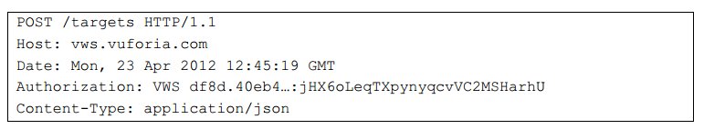

**Add new target**

**Request**:

POST – <https://vws.vuforia.com/targets>

Body of request contains the following fields

|  |  |  |
| --- | --- | --- |
| **Fields** | **Mandatory** | **Meanings** |
| name | yes | name of target |
| width | yes | width of target image |
| image |  | content of image encoded base64 (jpg and png format, maximum size is 2.25 MB) |
| active_flag |  | target is active or disable. |
| application_metadata |  | meta encoded base64 (maximum size is 150 KB) |

**Table 4-1 Fields in request body to create, update target.**

* image can be replaced by image_url, but not both at the same time.

**Respone**:

If everything success, service returns response in json format with the following fields

|  |  |
| --- | --- |
| **Fields** | **Meanings** |
| result_code | status: TargetCreated |
| transaction_id | id of transaction |
| target_id | id of target in database (used for updating, deleting the target) |

**Table 4-2 Return result of creation new target API.**

**Update target**

**Request:**

Similar to add new target but using the following address:

PUT – <https://vws.vuforia.com/targets/:targetid>

**Delete target**

**Request:**

DELETE – <https://vws.vuforia.com/targets/:targetid>

**Response**:

Similar to response of adding new target.

## 4.5. Result

Manager module has a nice user interface and easy to use. The service is currently deployed on Somee hosting - best free powerful hosting for ASP.NET website. Here are some pictures of the module.

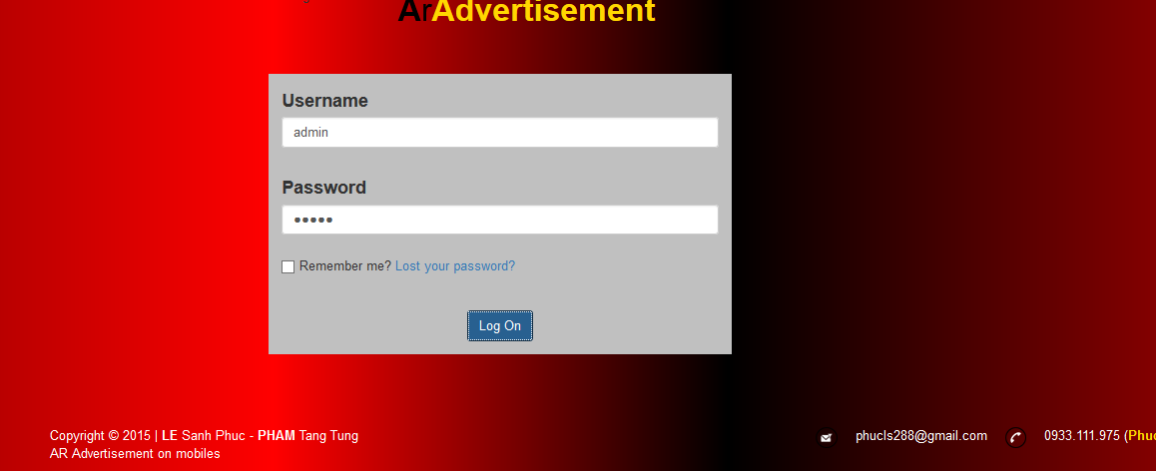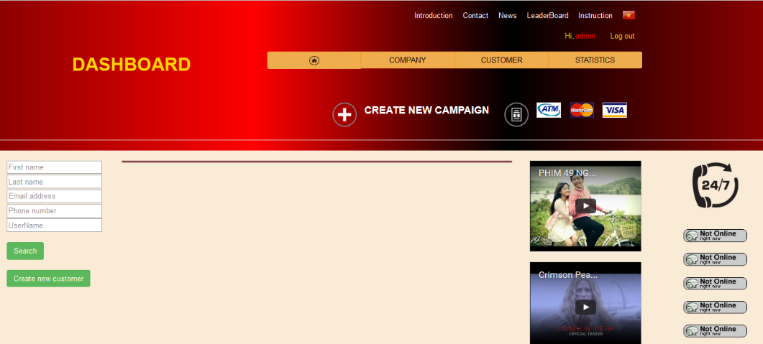

**Figure 4-15 Some pictures in manager module**

## 4.6. Conclusion

Manager module focuses on designing eye-catching interface, simple to use, providing marketing managers an easy working environment. It does not require high information technology knowledge to use the management website; users easily create advertising campaigns using augmented reality.

By using ASP.NET architecture, the website is designed in the way that is very compact lightweight, easy to grow in the future. The user interface of the site can be customized quickly, suitable for trend and demand of users without attention about the process of logic in the system due to the support of model.

# Chapter 5

**Architecture of presenter module**

*Content of chapter 5 includes architecture of presenter module as well as some problems when building this module on mobile device.*

## About presenter module:

Presenter module is an application built on Android platform and Vuforia framework. This module allows user to participate in the campaign and complete all missions built by managers. At each mission, user have to scans target (poster) then the system will query information related to the target and show on mobile screen for user. Besides, users can also comment and rate the campaign.

## Architecture of presenter module:

### Components in presenter module:

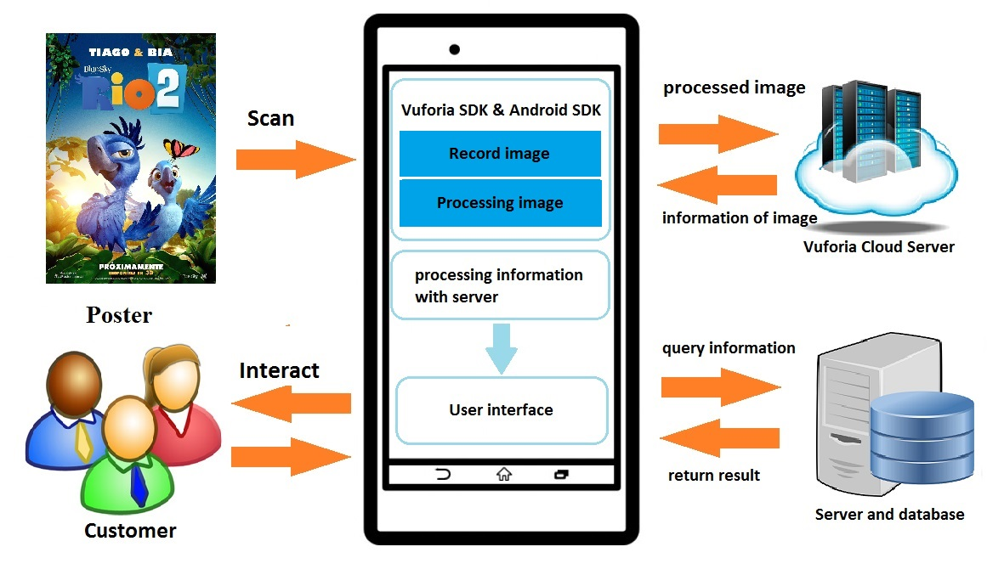

**Figure 5-1. Overall architecture of Presenter module**

Figure 5-1 demonstrates the overall architecture of Presenter module processing on mobile device. **Main components of this module includes**: **camera image handling components**, user interface component**s** and **server’s service interacting components.**.

* **Camera image handling components** will receive the recorded image.
* User interface displays information and supports user interacti**on** with augmented information.
* **Server’s service interacting components.**: the main channel of communication between devices and Cloud Server and Server. This is the most important component **of** the entire module.

### The process of identifying target:

**M**ain steps of this module includes:

1. Scan image of posters, magazines, newspaper…using device’s camera.
2. Vuforia contacts with identity service on server to query and get identification code (ID Target) corresponding to the image take**n** from camera.
3. By using identification code, the system queries corresponding specific description of augmented information.
4. The system uses specific description of augmented information to get augmented resources.
5. Show augmented resources on mobile screen.

Presenter module focuses on displaying augmented information as well as interaction among user and system. There are several type**s** of augmented information and each target contains some type of them which described in specific description file on XML format. Each time system gets specific description of augmented information from server, it handles receivedinformations to separate types of augmented information. Then depending on each type of information, management of augmented information objects modulewill use appropriate plug-in to process and display augmented information. (Figure 5-2)

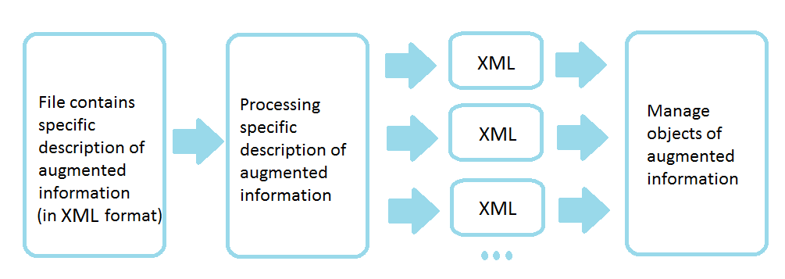

**Figure 5-2. Process of handling augmented information**

## Management of augmented information objects module:

In the model (Figure 5-3) consists of 3 components (classes) are: **ARResource**, **ARPresenter** and **ARActivity**:

* **ARResource**: **this** class contains augmented information of system. Subclass of this class contains some information such as text, youtube, picture and comment.
* **ARPresenter**: class are implement**ed** to manage displaying ARResource. Subclasses of this class is the ARProcessor which is responsible for handling information of ARResource class and displaying.
* **ARActivity**: class construct and manage user interface.

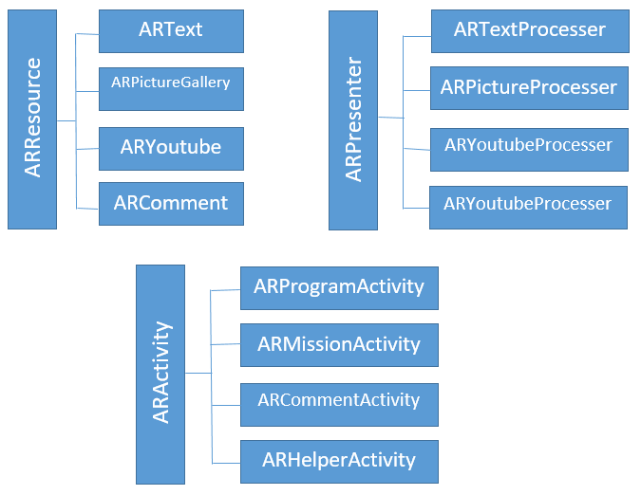

**Figure 5-3. Architecture of Management of augmented information object**

With the model we proposed, **this program can be managed and used easily**. With each augmented information corresponding to each module will handle how it works and displays. The strength of this architecture is that the latter not only apply to some types of information are available, even the kind of updates can be easily added and setup. Improving the scalability of the application. Architecture is expressed quite clearly in layers and how they communicate with each activity.

### Handling specific description of augmented information module:

After retrieving augmented information from the server in xml format, Presenter modules is responsible for analyzing those specific description to choose appropriate plug-in to process and display augmented information.

The structure of specific description file includes several components:

* **ARResources**: parent node contains all the augmented information of a specific object.

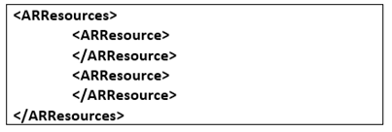

* **ARResource**: is a childe node of ARResources - this is a node presents a certain type of information. For example: ARText, ARYoutube, ... There may be one or more kinds of information for an object and all ARResource node are contained within ARResources parent node and is the same level together.
* **ARType**: show specific type of augmented information.



* **Attribute**: this node represents the attributes of specific type of augmented information. The same as ARResource node, Attribute node can have one or many. Besides, attributes of augmented information are divided into 2 separate categories: CommonAttributes (common attributes) and SpecialAttributes (special attributes) - the child nodes contained within these node are similar. Inside of the Attribute node includes:
* Key: contain keywords or unique identification number of attributes. To help determine the content of the attributes inside.
* Value: the value attached to the property.
* Extra: additional information for current attribute.

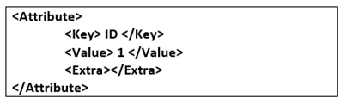

* **Tags**: this node marks some other information relevant to augmented information. This contains one or several Tag node. (This node is not implemented yet. This idea is suggested for developing in future)
* **Platforms**: besides providing augmented information, we need this node to decide which platforms it can run on. This node contains several Platform node.

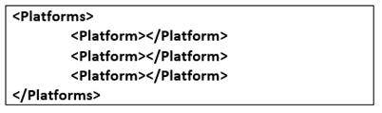

* **Platform:** contains information of a single platform. Including some below information:
* **PlatformID:** name **of** platform such as Android 4.2.2, …
* **Processors:** contains different Processor. The processor is a tool to build presenting augmented information on specific platform.

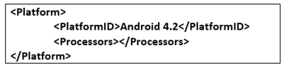

* **Processor:** the information needed for this node consists of two section:
* **ProcessorType:** type of presentation tool.
* **Data:** data used for the demonstration.

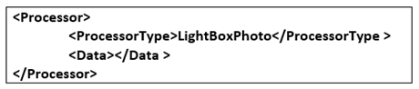

Thus, by using **the** above structure**s** to describe the augmented information, handling augmented information become clear and easy. In addition, designing above structure in XML format will easily improve in future: easy to add new type of information, additional platforms (Platform) or processing tool (Processor).

## Some problems and solutions to build presenter module:

### Develop database connections between Presenter module and Server.

1. **Problem:**

This is the main important problem in Presenter module. This module have some functions which need to interact with Server module such as log in, log out, load list campaign, load list mission, load augmented data for specific target. Therefore, we find out the way **which** Presenter and Server module interact to each other, so that the Presenter module can send and receive information easily.

1. **Solution:**

To build the connection between Client and Server, we suggest the solution as below:

* On Server module: we build a service which supplies some API function for Client us**age**. This service is built based on RESTful architecture.
* On Client (Presenter module): we declare a Service class, which allows sending and receiving data from server by implement**ing** two methods GET and POST. First, we use some libraries from Android SDK.

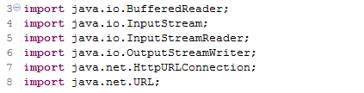

Before using above libraries, we need to declare permission to access Internet. In AndroidManifest.xml file, we declare the below permission:



To connect to Server on specific request URL, first we need to declare URL object:

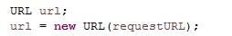

Then, we create a connection to the server by calling url.openConnection() and assign to HttpURLConnection instance. This instance uses the GET method by default. It will use POST method if setDoOutput(true) has been called.



For POST method, we need to transmit some data to server. We need to write data to the stream returned by getOutputStream(). To do this, we use OutputStreamWriter class.



After **the** request to server, we will use InputStreamReader class to get stream returned by getInputStream() and convert returned data to JSON object to analyze easily.

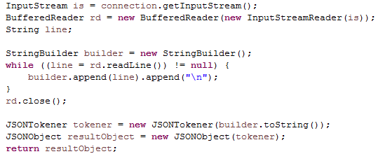

### Connecting to the network.

1. **Problem:**

When we try to call service to query information from server, we get an error named android.os.NetworkOnMainThreadException. This exception is thrown when an application attempts to perform a networking operation on its main thread.

1. **Solution:**

To prevent this exception, we suggest using AsyncTask class to perform the network operations on a separate thread from the UI. For example, with log in function, we declare class called LoginBackgroundTask which extends AsynTask and will call service in doInBackground() function.

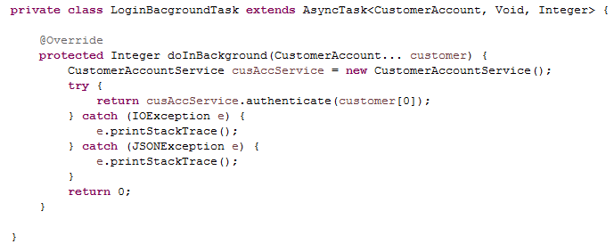

Then in event of Login button, we just need to declare an instance of LoginBackgroundTask and call execute() function to perform authenticate operator on separate thread.

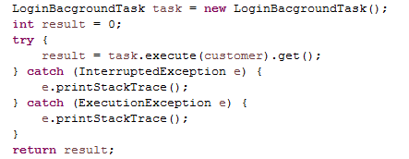

Usage of AsynTask class will be discussed at the next section

### Show list as listview in Android.

1. **Problem:**

Because of the characteristic of the program, template of items on ListView is built based on separate format. Another problem is each item on ListView contains an image which will affect the performance of list view. Then we have to find the way to enhance the performance of list view.

1. **Solution:**

* **Displaying layout of ListView** **as expected:**

We suggest using solution custom layout for ListView. For ListView **to display** list of campaigns, first we declare a layout called program_list_item.xml and then add some widget presenting information such as image (ImageView), Name (TextView), Description (TextView)…in a format we expected. Then, we need to declare an adapter class which is responsible for reconfiguration each item in list view. Corresponding with each Program item, adapter will handle and assign attributes from Program to widgets of item. After building adapter successfully, we use method supported by Android SDK (ListView.setAdapter(customAdapter)) to attach adapter into ListView. Finally, we call function updating UI of ListView: ListView.notifyDataSetChanged().

Interface of ListView is updated completely as desired.

* **Improving the performance of ListView:**

To solve this problem, we suggest using Multithreading by using AsynTask class.

AsynTask is a class which allows moving the time-consuming handling to background thread. This class supplies asynchronous process and publish results on the UI thread when completing.

To create an asynchornous task, we have to create a class extend AsyncTask and specify 3 generic types: Params, Progress, and Result.

* Params: parameters are sent to the task upon execution.
* Progress: the type of the progress units published during the background computation.
* Result: type of result returned after completing.

If we do not need to use three of them, use Void for all.

When extend AsyncTask class, this subclass can override some methods:

* onPreExecute(): this will execute first when subclass is called
* doInBackground(Params…): this function **will be** invoked on the background thread after onPreExecute() finishes executing. This method cannot interact with UI objects (can not set text for TextView or show Toast…). Because this method is used to perform background computation so it take**s a** long time. We can use publishProgress(Progress…) to publish units of progress, then onProgressUpdate() will display progress on UI.

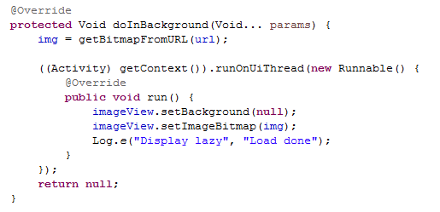

* onProgressUpdate(Progress…): receives parameters from publishProgress() function and display information (progress bar or show log) on UI.
* onPostExecute(): invoked when doInBackground() finish executing. It receives result as parameter form doInBackground().

By applying Mutithreading, ListView can be load smoothly.

### Display augmented information on Camera

1. **Problem:**

After **the poster is scanned succesfully,** augmented information will be display**ed** on mobile screen. The problem is how to display those information (image, video…) directly on Camera.

1. **Solution:**

Structure of augmented information will be analyzed by **handling specific description of augmented information** module. We researched about the way Vuforia presents augmented resources on camera. They use OpenGL to draw those resources on camera screen based on Renderer class.

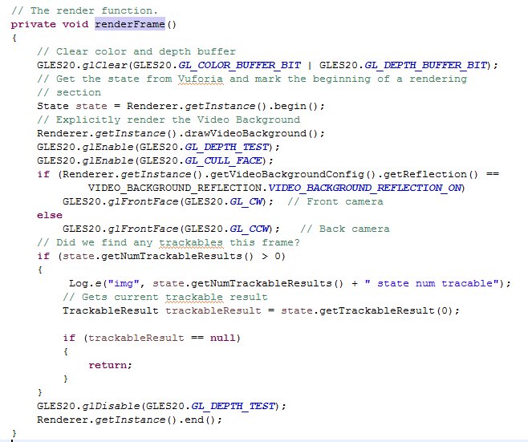

However, to simplify and facilitate the presentation of augmented resources in complex formats such as audio, video ... **we** used a different approach to demonstrate the enhanced resources. It is the use **of** LayoutInflater, this is a class that Android offers to transfer control widget from XML into the instance for use in code. The augmented resources when downloaded will be analyzed and transferred to the corresponding class resource types that to turn into the widget and add on top of the camera's layout.

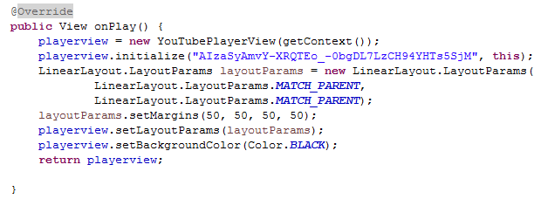

With this method the resources will be converted to the widgets display enhanced content in a customized way. We can change the demonstrat**ion of** an augmented resource easily by modifying the corresponding presentation class. Also, when there is a new enhanced resources we just need to design a class to analyze the content of resources, a class present that content into the desired widget. It will not need to change the structure of the system when adding new kinds of enhanced resources.

### Demonstrating augmented information

1. **Problem:**

For complex augmented information as a set of images, a movie or video, our group had to build its own class to analyze and demonstrate this enhanced information on mobile device.

1. **Solution:**

* **Augmented information is a set of images:**

Initially **we** just learned and performed a single image to enhance information for target (poster). However this limits the number of enhanced images for target. Therefore **we** suggest build**ing** a new type of enhanced resource, a picture gallery. Then, we build a ARPicturesProcessor class to demonstrate the picture gallery.

ARPicturesProcessor class use ImageSwitcher widget to contain set of images in ImageView format.

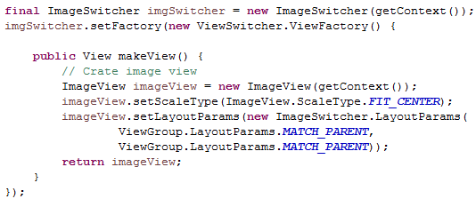

Then, to create the effect of switching to the next picture, we also build animation for this widget. Users simply slide left or right to view the corresponding pictures.

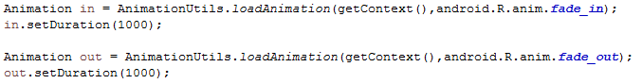

* **Augmented information is a video:**

Video is **a special** type of information and Youtube is a huge source of videos. Therefore, **we** decided to use **this** giant video source **of** Youtube **to enhance** information for the target. Using video on Youtube is not only increase **community strongly**, spread enhancement products widely but also ensure quality and content of the video. However the issue of showing and playing video on the device is a difficulty of group. The group has proposed two methods to play this video on the device:

* Use VideoView widget: This method encounters a major problem when playing Youtube videos, they do not allow their videos **to be** displayed by the other movie player program that has not been licensed. We can try to get their link, but only link of the formats 3gp video which is low quality. And the video link at the other servers are scarce and there are no guarantees about the content and quality.
* Use Youtube Data API: **we choose** this method because it ensures video transmission speed, image quality.

## Result

Presenter module is built and run stably, functions properly with this module's objectives: enrolling a campaign, do mission of that campaign, the camera operates efficiently in detecting and identifying the image object using augmented reality technology, solve all encountered problems.

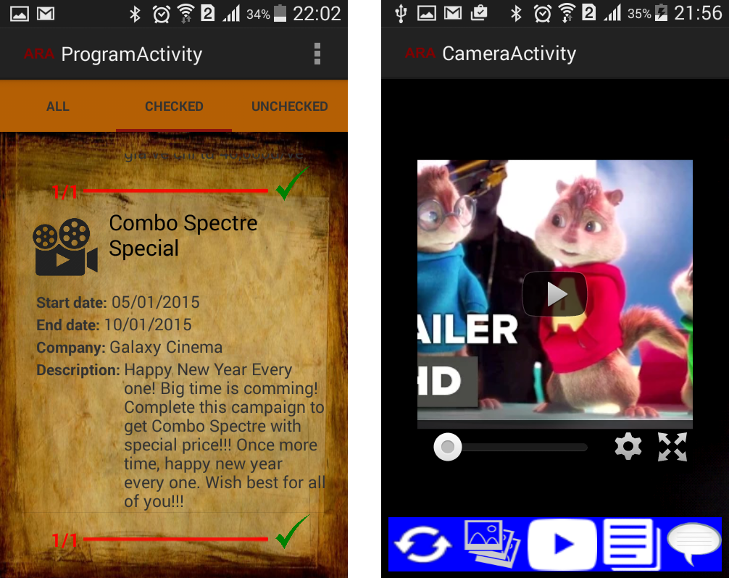

**Figure 5-4. Demo about Preseter module**

## Conclusion

In this chapter, we introduced about overall architecture of Presenter module. Based on architecture and above solutions we built Presenter module which analyzes augmented information and displays them on mobile screen.

# Chapter 6

**Summary**

*In the chapter, we summarize the achieved result of group on Manager and Presenter modules. The contents of this chapter also mention about the future development of the system.*

## 6.1. Results

Objective is to propose solution to apply augmented reality in improvement the advertising process, the interaction between customers and managers marketing strategies. First, the solution provides managers a design tool to design augmented data and augmented activities for each product, which needs marketing, advertising, and give them an important statistics on the rate of attended customers in each campaign, so they can understand the trend of customers and continues to build new promotional marketing strategies effectively. Then, we supply for customers diverse augmented reality information related to augmented resources such as image in ***multimedia*** (banner, poster, logo…) including multi-media information (image, video, sound, text,…) as well as ***social media*** information (comments, discussion in forum, videos, relative text in the Internet). Moreover, the solution also improve the ***interactive*** of customers through attractive ***activities*** to make people be interesting with new products by doing experience or ***like, share*** in popular social networks such as Facebook to broadcast to a large number of customer. The system supplies for customers another way to comfortably approach with new products

The solution has two primary components: (1) websites for marketing managers to quickly and effectively manage. They can easily ***build, design information and augmented activities*** associated with product as well as create ***a bridge between marketers and customers*** to improve advertisement services; (2) the image processing and showing augmented information in mobile devices using Vuforia SDK. Today, mobile devices allows customers to get more necessary augmented information. This helps them to answer their questions when they decide to choose any new products, and they also have new promotion information with just simple clicks.

During the research time, we use the basic knowledge and features of Vuforia to build the system. The contents are presented in the previous chapters of the thesis. By the rapid development of processing algorithms and the improvement of hardware, in the near future***, augmented reality*** are applied in many aspects of life; especially the advertisement.

The system uses 3-tier architecture for future development and maintenance. This also improve the performance.

In the thesis, group uses Vuforia framework of Qualcomn to recognize and show augmented information. During the research time, we understand the flow activities of the library to serve ***presenter module***. We can also use the API supplied by Vuforia to create database of the system through ***manager module***. In the scope of the topic, we do not research about the development and improvement of image recognition algorithm in Vuforia SDK. Moreover, group presents some process to use manager module.

Group builds 3 type of campaigns, and input 8 campaigns for testing. Three type of campaign was built are:

* **Check-in:**

User just need to go to one of those places which are list in campaign to check-in and get the corresponding rewards.

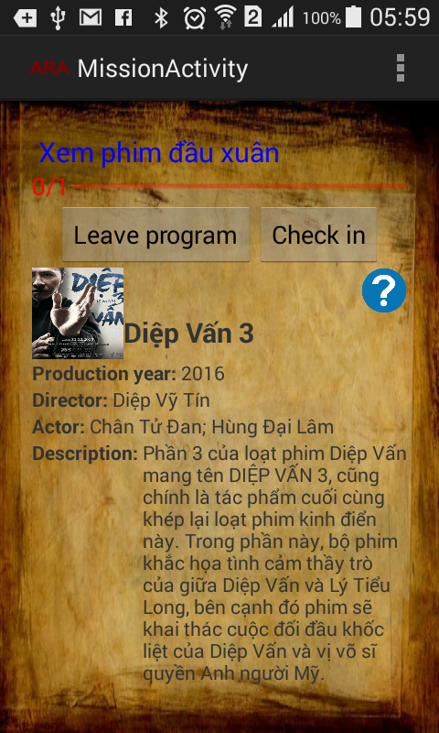

**Figure 6-1. Check-in campaign**

* **Theater:**

The management usually expect customers know about their movies. Campaign required user research about a movie by scan poster of that film and then after complete, user will receive the reward.

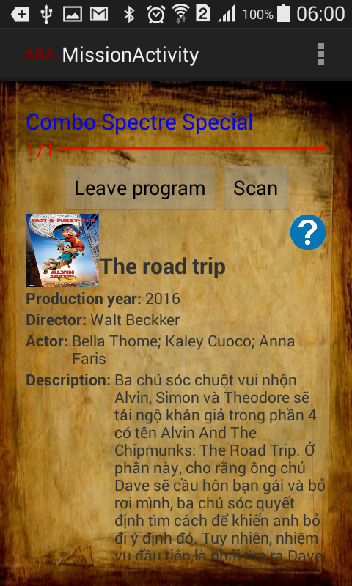

**Figure 6-2. Theater campaign**

* **Tour:**

This is the campaign which encourages user go to some place and scan poster of movie at that place. After go to all place and complete all missions, user will receive the reward from management.

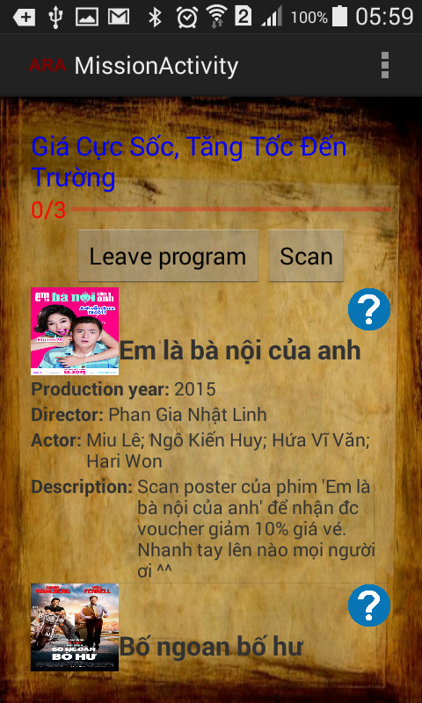

**Figure 6-3. Tour campaign**

Some archive results on Management module:

* This module is built on ASP.net platform, using ASP.net Webform technology.
* Graphic user interface (GUI) is simple, easy to use which bring to user comfortable usability in process of using.
* Support some kind of information such as multi-media, social-media, and interactive activity. Therefore, this system improves the interaction between managements and user. Everything is performs on mobile device. Especially, kinds of information resource and interactive activity can be implemented flexibly later.

Some archive results on Presenter module:

* This module allows user using their android mobile to scan on images and watch augmented information.
* User can interact with augmented information object to watch information of movie as well as rate and comment about that movie

## 6.2. Development

By using augmented reality with intelligent interactive way, customers have very interesting experience, improve quality information and attracting the attention of customers. In the scope of the topic, we forward to understand and develop a solution in augmented reality to run trail system for advertising movies. This is one of the first steps for group before going to research, analyze and develop real application to improve operations advertising at the moment, and so fare are many aspects of society, such as reading books, games play, inform, educate ...

In the topic, the group give some solutions to be developed:

* Redesign interfaces in both modules more professional that are suitable for each content of different products. Because the topic is in advertising section, the interface must be eye-catching and attract the attention of photosynthesis viewers. For each specific product types, we should have the corresponding interfaces following the trends of customers.
* Improve the transfer speeds between databases and the modules. Developing more the image processing tools for the reason that are not depended on Vuforia. Processing speed of system heavily dependents on data transmission speed, so in order to add more information for users, we need to have a fast system, hardware devices should be upgraded to improve performance of system.

For the development of management modules:

* Support three-dimensional model resources in some game engines and specific resources each product.
* Support new users to define a new augmented information.
* Support multiple different modules of many specialized products.

For the development of demonstration modules:

* Support displaying three-dimensional model.
* Optimizing the performances / shows the augmented information. At the moment, in the system, these information are displayed by widgets provided by Android. To increase the professional and nice to have the presentation, this needs to have new way. •
* Support for more interactive activities to bring new, unique, fun points for advertising. The system currently only provides two active trials interactive advertising campaigns. The development of new interactive activities attract new marketers.
* Assist in identifying sound, augmented information displays when users read keywords or product names. Identification sound instead of images recognition make the system having new development trend in more exciting way that allows users to have a completely new experiences.
* Develop the system on iOS devices, Windows Phone help system having larger customers. If we just concentrates on particular operating system, we lose a number of people in other operating systems.

# REFERENCES

[1] R. T. Azuma, "A Survey of Augmented Reality," Malibu, 1995.

[2] genk, "Augmented Reality – Chân trời mới của thế giới công nghệ không còn quá xa vời," genk.vn, 30 june 2012. [Online]. Available: http://genk.vn/pc-do-choi-so/augmented-reality-chan-troi-moi-cua-the-gioi-cong-nghe-khong-con-qua-xa-voi-2012062912589808.chn.

[3] AF-STUDIO, Super Monitoring, "Infographic: 2013 Mobile Growth Statistic," Digitalbuzzblog, 1 10 2013. [Online]. Available: http://www.digitalbuzzblog.com/infographic-2013-mobile-growth-statistics/.

[4] NguyenMauTam, "Quảng Cáo là gì ?," Vnecon.vn, 8 4 2008. [Online]. Available: http://www.vnecon.vn/threads/quang-cao-la-gi.1122/.

[5] Infonet, "Thời của quảng cáo trên thiết bị di động lên ngôi," Vietnamnet, 2 7 2014. [Online]. Available: <http://vietnamnet.vn/vn/cong-nghe-thong-tin-vien-thong/183865/thoi-cua-quang-cao-tren-thiet-bi-di-dong-len-ngoi.html>.

[6] AF-STUDIO, Super Monitoring, "Infographic: 2013 Mobile Growth Statistic," Digitalbuzzblog, 1 10 2013. [Online]. Available: http://www.digitalbuzzblog.com/infographic-2013-mobile-growth-statistics/.

[7] "Tối ưu hóa chiến dịch khuyến mại của doanh nghiệp," Báo doanh nhân sài gòn điện tử, 02 08 2010. [Online]

[8] B. Insider, "11 Amazing Augmented Reality Ads," Business Insider, 28 1 2012. [Online]. Available: http://www.businessinsider.com/11-amazing-augmented-reality-ads-2012-1#net-a-porter-makes-storefronts-interactive-1.